2.4 Building Condition

2.4.1 The Consultative Document issued in November 2007 highlighted the fact that Witchhill School required capital investment of £611,000 to bring it to a modern standard. Woodstock School required £670,000 to refurbish the building’s existing components.

    - To assist Cabinet in considering the outcomes of the consultation and to best inform deliberations a re-survey on the schools was carried out in February 2008. This ensured that reinstatement costs for the school building reflect current prices. It should be noted that while an exercise is undertaken annually to update Core Fact data on the school estate for the Scottish Government, this was brought forward to inform this proposal. This work was undertaken jointly by officers from Education and Property Services, with the results being costed by Quantity Surveyors from Technical Services. The results of this exercise have provided an up to date knowledge of the required capital investment as highlighted below. In summary, the estimated capital requirement in the next 10 years is now calculated to be £710,000 for Witchhill School and £793,000 for Woodstock School. A breakdown of the component factors and rating is detailed below.

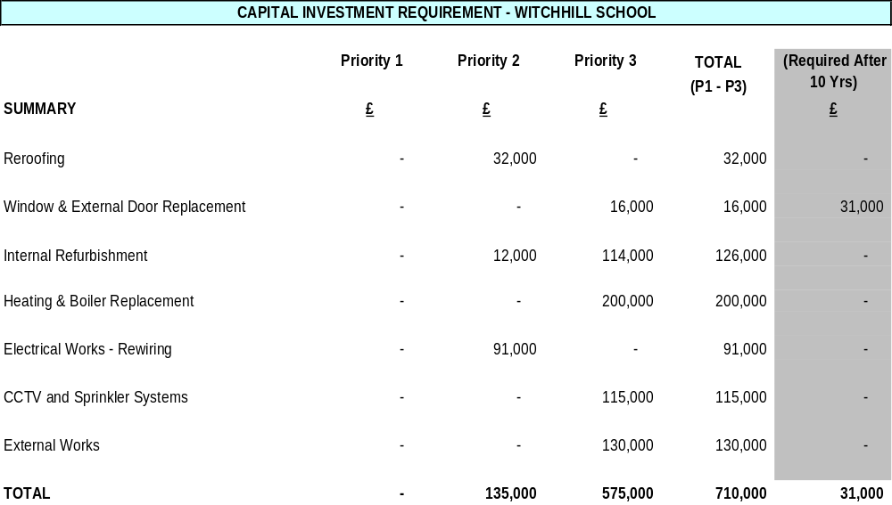

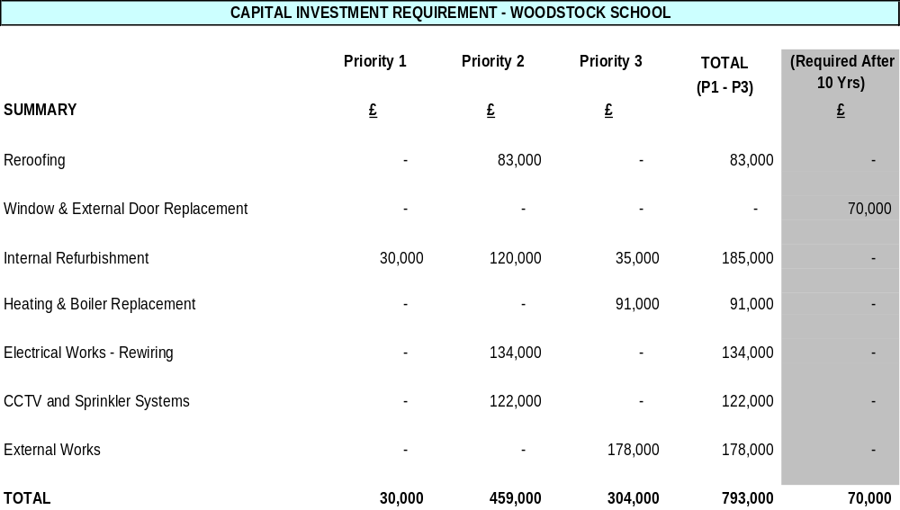

2.4.3 As stated, the projected future 10 year investment costs for both school buildings have been calculated to be in the order of £1,503,000. Such investment requirements coupled with a current pupil rolls of 5 and 29 respectively, as at 25 February 2008, does not reflect efficient use of the Council’s resources.

2.5 School Information

2.5.1 Pupil Roll Data

Witchhill School
The pupil roll reported at the September 2007 census was 5. At 25 February 2008 the roll had remained at this level.

Woodstock School
The pupil roll reported at the September 2007 census was 29. At 25 February 2008 the roll had remained at this level.

2.5.2 Number of pupils from other authorities

At present there are no pupils attending either school from other local authority areas.

2.5.3 Attainment data

Pupils at Witchhill and Woodstock have their learning and care needs met through individualised learning plans. Curricular programmes are delivered at a pace and level appropriate to individual children and young peoples’ needs. For a number of the children, the curriculum is accessed through sensory and tactile programmes. A critical focus for older pupils, particularly at Woodstock School, is life skills. Celebrating success is a key feature threaded throughout curricular programmes.

2.5.4 HMIE Report Outcomes

Witchhill School
The most recent HMIE report on Witchhill School was issued in April 2005. HM Inspectors comments are detailed below :-
“HM Inspectors identified the following key strengths.
- Care, welfare and health needs of pupils ably met by an extremely committed staff, who worked very well as a team, including the valuable contributions made by support agency personnel.
- Partnership with parents and carers and parental support for the work of the school.
- Staff’s effective manual handling of pupils and the care taken to ensure pupils’ functional movement skills were suitably maintained and developed.
- The school’s welcoming and calm ethos in which pupils were valued as individuals.
Main points for action
The school and education authority should take action to improve aspects of learning and teaching, staff development and arrangements for transfer to post-school placements. In doing so they should take account of the need to:
- develop the curriculum to provide pupils with learning opportunities at Access Level 1 and to have their achievements recognised through national certification;
- continue to develop sensory and tactile approaches to enhance learning and teaching;
- improve assessment procedures for children and young people with multiple disabilities and continue to develop ways of using learning targets within individualised educational programmes to focus teaching activities;
- ensure staff receive child protection training and have opportunities to engage in training relevant to working with pupils with complex additional support needs and multiple impairments;
- work with parents and support agencies to consider how the constraints of the present accommodation and low pupil numbers can be overcome; and
- develop, in partnership with other relevant support agencies, more effective procedures to deliver appropriate post school placements for young people and at the point of need.”
Woodstock School
Woodstock School has not been inspected in the lifetime of East Ayrshire Council.

2.5.5 Number of staff by category – Witchhill School

Teaching Staff

Using Council formulae the school is entitled to a teaching cohort of 2.0 FTE (full time equivalent)

Ancillary Staff

In addition to the teaching complement Witchhill School has 1.5 FTE instructors, 0.75 FTE clerical support, and 1.1 FTE classroom assistants and 1.8 FTE manual workers. Janitation and cleaning support 21.00 hours are allocated to the school and one individual performs these tasks.

Number of staff by category – Woodstock

Teaching Staff
Using Council formulae the school is entitled to a teaching cohort of 7.95 FTE (full time equivalent).

Ancillary Staff

In addition to the teaching complement Woodstock School has 4.0 FTE instructors, 1.0 FTE clerical support, and 3.3 FTE classroom assistants. Janitation support of 1.0 FTE (37 hours per week). Cleaning hours of 26.80 hours are allocated to the school and two individuals perform this task.

2.5.6 List of extra curricular activities

The Head Teacher of Witchhill School has advised that there are no extra curricular activities due to the medical condition of the children and young people attending. At Woodstock School there are Yoga, Aerobics, Dance, Boys and Girls clubs, and Motivator Activities sessions.

2.5.7 Inclusion

The Council is committed to a policy of inclusion. A number of changes in legislation (principally the Education (Additional Support for Learning) (Scotland) Act 2004) bring obligations to ensure that all have equal access to facilities. Possibilities offered under this proposal would address a number of issues related to equal access.

3. THE CONSULTATION

3.1 Written representations on the Cabinet’s proposals were sought from interested parties in terms of the Education (Publications and Consultation etc) (Scotland) Regulations 1981 and Amendment Regulations 1987, 1988 1989 and 2007.

3.2 In accordance with statutory requirements, parents of affected schools and the appropriate parent councils have been consulted. Copies of the consultative document were also made available to the staffs of Witchhill Special School, Woodstock Special School, Grange Academy, Kilmarnock Academy, Kirkstyle Primary, Hillhead Primary, Loanhead Primary, Bellfield Primary, Gargieston Primary, Shortlees Primary, Annanhill Primary, Crosshouse Primary, representatives of teacher and staff unions, the appropriate Members of the Scottish Parliament and the appropriate Member of Parliament. Pupils were also given the opportunity to provide comments on the proposals.

3.3 The existence of the document was publicised in the press and copies were made widely available in the local community and to local interest groups. Additional copies of the Consultation Document were obtainable from the Department of Educational and Social Services, Council Headquarters, London Road, Kilmarnock, from the schools involved and through the Council Website at www.east-ayrshire.gov.uk

3.4 A number of meetings with stakeholders took place during the consultation process. This included a public meeting arranged in partnership with the Parent Council of Woodstock School. The meetings were attended by parents, staff and members of the community. Parents of children attending Witchhill School did not feel they required a public meeting as they were broadly supportive of the proposals.

3.5 Meetings offered the opportunity for discussion and clarification of the proposals as well as a forum for people to express their views of the consultation proposals. Those organised for members of the community were well attended and gave the opportunity for very many views to be expressed.

3.6 An important aspect of consultation in respect of Witchhill and Woodstock Schools was NHS Ayrshire and Arran. This reflects the significant health care needs of many of the pupils attending these schools.

4. RESPONSES TO THE CONSULTATION

4.1 In addition to the 51 written submissions received, the meetings referred to above enabled a number of significant issues to be raised. The following paragraphs summarise the issues raised at the meetings and in the written responses to the consultative documents. Every effort has been made to summarise views as accurately as possible and, where appropriate, to give a response. These groupings are as accurate as could be determined, however it was not always clear from responses whether they were written by a staff member, a parent or another interested party. Submissions included responses from:

- Witchhill School Parent Council
- Woodstock Parent Support Group
- Questionnaires completed by 35 Woodstock School pupils
- Darvel Primary School Parent Council
- Dalrymple Primary School
- Acting Head Teacher Witchhill Special School
- Head Teacher, Woodstock Special School
- Kilmarnock Learning Partnership (Educational Establishments)
- Kilmarnock Academy
- Cumnock Academy
- Individual parents and relatives
- Staff of Witchhill School
- Staff of Woodstock School
- School Nurse of Witchhill School
- Advanced Clinical Specialist for Special Needs
- Speech and Language Therapy
- NHS Community Physiotherapist
- Other interested individuals

  - Public Meeting - Woodstock School – 9 January 2008

4.2.1 A public meeting was held at Woodstock School on 9 January 2008. This meeting, was chaired by a representative of the Parent Council of Woodstock School and addressed by the Executive Director of Educational and Social Services.

4.2.2 Those present were in agreement with the proposal to merge the two schools.

4.2.3 The view was expressed by several of the audience that the Park School site, Option 4 in the consultative document, would be the preferred site for the merged school, on the basis that it was centrally located, close to local amenities, including the Dick Institute and with good transport links. It was also felt that the local community would be supportive of a new special school in the area.

4.2.4 A number of issues were raised:

- would the available budget be adequate to avoid compromising on resources?
- could the timescale be met?
- would there be spare capacity to accomodate an increase in the roll? In response to the answer that the new school would have 40 places, the comment was made that 45 would be preferable, given the increasing survival rate of children with multiple disabilities.
- could the existing pool be used at the Park School site?
- what would the new school be called?
- could other staff teams be accommodated on the site?

In response, the Executive Director indicated that services would be developed based on children’s needs. For example, parents asked about the possibility of retaining the Park School hydro-therapy pool. It was noted that whilst there may have to be a prioritisation of requirements staff, parents and the young people would be fully consulted at every stage. It was recognised that the timescale was ambitious.

4.2.5 It was stated that if the merger goes ahead, there would be a further consultation on a name for the new school.

4.3 Witchhill School Parents’ Council

4.3.1 A submission from the Witchhill School Parents’ Council welcomed the consultation, agreed with the proposal that the two schools should merge and expressed a strong preference for Option 4, a new build school on the site of the current Park School. The site would be easily accessible, allowing pupils easy access to local resources, the town centre, St. Joseph’s Academy complex, Kay Park and other local amenities. Older students would be able to access Kilmarnock College. The importance of good communication with, and access to, health services was emphasised.

4.4 Woodstock Parents’ Support Group

4.4.1 The chairperson of the Woodstock Parents’ Support Group expressed the group’s preference for a new school on the existing Park School site, Option Four. In addition to reasons listed earlier, it was noted that the adjacent roads already have traffic calming in place and that there was room at the site to provide all desirable facilities with scope for expansion. This response also made the point that the proximity of the new school to mainstream establishments, which if built at the Park School site, would be to the mutual benefit of the new school and of the mainstream schools.

4.5 Pupils of Woodstock School

4.5.1 Thirty-five pupils of Woodstock School completed a pictorial proforma on which they were asked a number of questions about the current facilities in the school, for example, toilets; room to play; a good gym and whether or not they needed a new school. Older pupils were also asked to comment on where they would like their new school to be located and their reasons for their preference.

4.5.2 In general, the view was that existing facilities were unsatisfactory. All 35 young people considered that they needed a new school. Eleven pupils commented where they would like the new school. Of these, 8 preferred the Park School site and two wanted the school to be kept at its current location. One was in favour of Option 6, a new site, unspecified. Reasons given in favour of a new school were the wish for: a bright new school with lots of space; bigger classrooms; a room for computers; a big gym; a swimming pool and a new art room.

4.6 Witchhill School Staff

4.6.1 In a detailed response, the staff of Witchhill School acknowledged that the unsatisfactory state of repair of the school buildings, the poor design of the school for the delivery of the modern school curriculum and the inefficient deployment of staff resulting from the small pupil numbers all pointed to the desirability of merger with Woodstock School. It was recognised that there were long term financial and educational benefits to be gained from bringing both schools together in a single complex where pupils would benefit from the most up to date resources to support their education.

4.6.2 The staff response examined each of the 6 options in turn. Option 1, the status quo, was not felt to be viable for the reasons already given. Options 2 and 3, to locate the merged school on either the existing Witchhill or Woodstock sites, were discounted on the basis that both sites were cramped and would restrict design options for the refurbished school. In addition, the disruption to pupils’ schooling was considered to be unacceptable. Option 4, to locate the new school on the Park School site, was the favoured option on the basis that it is centrally located in Kilmarnock, it is already known as the location of a special needs school, it is close to the St. Joseph’s campus and to Kilmarnock College and it would be possible to create a new building there with state-of-the-art facilities without any disruption to pupils’ education.

4.6.3 Staff believed that Option 5, to locate on the St. Matthew’s site, was the second choice option if, for example, the Park School site was too small to accommodate the new build. Option 6, to locate to a new and as yet unidentified site had potential benefits similar to Options 4 and 5 but it was considered unlikely that a suitable and affordable site could be acquired within a reasonable time frame.

4.7 Acting Head, Witchhill School

4.7.1 In a separate, individual response, the acting head of Witchhill School endorsed the staff views. Park School site was the preferred location for the new school, so long as there was sufficient space. Failing that, the St. Matthew’s site was the acceptable alternative, although the acting head was also concerned about the use to which the surplus land might be put.
4.8 Woodstock School Staff

4.8.1 Members of staff of Woodstock School submitted a total of 15 individual responses.

4.8.2 The head teacher’s response endorsed the need for a new school and indicated that Option 4, the Park School site, was the preferred option. The reasons given are almost identical to those expressed by the acting head and the staff of Witchhill. The head teacher’s response stressed the urgency of building the new school, given the inadequacy of existing accommodation. A response from the depute head teacher of Woodstock School also favoured Option 4.

4.8.3 Thirteen other staff members at Woodstock School responded, and all but one were in favour of the proposal to merge the two schools. Two staff members favoured Option 3, the Woodstock site as the location for the new school. One of these suggested Option 6, a new site, as the preferred alternative. The other 11 responses favoured Option 4, the Park School Site.

4.8.4 One of the responses in favour of retaining the Woodstock site argued that it had good access to local amenities. The other noted that it was the ideal location for post-16 special education and it had the best route into town for wheelchair-bound students.

4.8.5 Of the 11 responses favouring Option 4, two of these commented that Woodstock was a better site but they came down in favour of the Park School site because of the disruption to pupils that the building process would involve if the Woodstock site were chosen.

4.9 Kilmarnock Academy Learning Partnership

4.9.1 This response, from the chairperson of the Kilmarnock Learning Partnership on behalf of the educational members of the Partnership, endorsed the proposal to build a new school and favoured Option 4, the Park School site. It stressed the need for a protected environment for vulnerable children and the importance of retaining the “close and mutually supportive” relationship between Witchhill School and the Kilmarnock Learning Partnership, specifically links with support staff, Hillhead Primary School and Kilmarnock Academy.

4.10 Other Group Responses

4.10.1 The Parent Council of Darvel Primary submitted a general response expressing support for the core principles of the document ‘Better Schools: Better Learning’.

4.10.2 The Dalrymple Primary Parent Council agreed with the proposal to merge Woodstock and Witchhill Schools, stating that a unified and quality provision would be of great benefit to pupils and the community.

4.10.3 A response by the head teacher of Cumnock Academy on behalf of the school’s senior management team, although not commenting on specifics, as they pertained to individual schools, confirmed that they were in favour of the process and noted the Council’s commitment to use all savings and capital receipts to improve the education of the young people of East Ayrshire.

4.11 Responses from Parents and Close Family Members

4.11.1 Twenty individual letters were received from parents, carers and relatives of pupils at the two schools.

4.11.2 All of these responses were in favour of the proposal that the two schools should merge. Furthermore, they all supported Option 4, merger on the Park School site.

4.11.3 The reasons listed in these letters are as detailed earlier and can be summarised as: access to town centre amenities; proximity to mainstream schools; avoidance of unnecessary disruption at construction stage; unsuitability of existing Woodstock and Witchhill sites for new merged school.

4.11.4 Additional points from the individual letters include the folllowing:

- one respondent suggested that a new school for 40 pupils was not big enough;
- three of the letters suggested that there should be provision for 18 – 25 year olds, as they felt this age group’s needs are neglected at the moment;
- refurbishment of either of the existing schools should be rejected on grounds of cost and feasibility;
- merger of the two schools would pool the considerable expertise that exists at each.

4.12 Individual Responses from Teachers and Other Professionals

4.12.1 A further 7 or 8 responses were received from individual members of teaching and support staff at Witchhill, and other professionals supporting the schools.

4.12.2 A response from the Clinical Specialist for Special Needs, Speech and Language Therapy, reiterated the arguments put forward earlier and supported a proposed merge on the current Park School site . It was noted that merger would bring together the considerable talents of staff and would allow pupils to access more areas of the curriculum than are available to them at present. Similar views were also expressed by the school nurse at Witchhill and an NHS physiotherpaist.

4.12.3 A letter from the School Chaplain expressed wholehearted support for the proposals and highlighted the inclusion opportunities for pupils that would result from the merger.

4.12.4 One response, from a teacher at Witchhill, favoured the Park School site but suggested that instead of merging, the two schools should be co-located and should continue to operate as separate establishments, each with its own management structure. This response also suggested that the St. Matthew’s site would be a suitable alternative, should the Park School site not be suitable.

4.13 Many respondents took the opportunity to express the desire for ongoing consultation to take place, if approval was given to merge the schools. They particularly wanted to be involved in the design of any new facilities, particularly given the health care needs of many children attending both schools.

5. COMMENTS ON THE VIEWS EXPRESSED

5.1 The issue of the consultative document raised considerable interest and concerns amongst staff, parents/carers, parent’s councils, community groups and other interested parties. The number of written responses and the level of attendance and questioning at meetings confirms the important place that these schools have in the community. It underscores the real interest that parents and others have in the quality of education and care that their children receive and particularly the concerns that parents and others have over proposals for change to the existing arrangements.

During the consultation period a number of general issues were raised that relate to the proposals for this establishment and others that were identified as part of the “Better Schools: Better Learning” initiative. These general matters are considered in a separate report to Cabinet namely, the nature and conduct of the consultation exercise, the accuracy of information, the basis of costs, GAE funding, calculation of school capacities and roll projections.

5.2 The Educational Case

5.2.1 Option 1 – Status quo: maintain both schools as they currently exist

The only educational advantage of the status quo is that it would involve no disruption for the pupils of either school.

The educational disadvantages of the status quo are

- the buildings of both Witchhill and Woodstock Schools are in poor condition and are not suited to the delivery of the modern curriculum;
- they fail to give pupils the benefits that up-to-date equipment, geared to their needs, would provide;
- the buildings are not fully compliant with the requirements of the Disability Discrimination Act

5.2.2 Option 2 - Locate a merged school on the current Witchhill site

The educational advantages of option 2 are

- merger of the two schools would bring together the best of each in terms of resources and talents;
- extension and refurbishment of the building would introduce many of the features of a modern school that enhance teaching and learning;
- merger would benefit the social development of children;
- the merged school would be better equipped than either of the schools individually;
- the central location would enable strong links to develop with mainstream schools and Kilmarnock College;
- nearness to the town centre facilities and Kay Park would enhance the curricular experience for pupils.

The educational disadvantages of option 2 are

- refurbishment and extension of the school on this site would restrict design options and external space, due to the limitations of the footprint of available land;
- refurbishment would cause disruption to the education of pupils currently attending Witchhill School, who would have to be relocated during this period.

5.2.3 Option 3 - Locate a merged school on the current Woodstock site

The educational advantages of option 3 are

- merger of the two schools would bring together the best of each in terms of resources and talents;
- extension and refurbishment of the building would introduce many of the features of a modern school that enhance teaching and learning;
- merger would benefit the social development of children;
- the merged school would be better equipped than either of the schools individually;
- the central location would enable strong links to develop with mainstream schools and Kilmarnock College;
- nearness to the town centre facilities would enhance the curricular experience for pupils.

The educational disadvantages of option 3 are

- refurbishment and extension of the school on this site would not enable all of the desirable design features of a new build school to be introduced, due to the limitations of the footprint of available land;
- refurbishment would cause disruption to the education of pupils currently attending Woodstock School, who would have to be relocated during this period.

5.2.4 Option 4 - Locate a merged school on the site of the present Park School

The educational advantages of option 4 are

- a new build school would incorporate state-of-the-art design features, technological aids to learning and specialist equipment;
- merger of the two schools would bring together the best of each in terms of resources and talents;
- merger would benefit the social development of children;
- the merged school would be better equipped than either of the schools individually;
- the central location would enable strong links to develop with mainstream schools and Kilmarnock College;
- nearness to the town centre facilities and Kay Park would enhance the curricular experience for pupils;
- building on a site away from either school would avoid disruption for staff and pupils during the building phase;
- the opportunity to take full advantage of the outdoor environment as another learning area.

The educational disadvantages of option 4 are

- location of the new school on a main road may require additional traffic management measures to be introduced.

5.2.5 Option 5 - Locate a merged school on the site of the present St. Matthew’s Primary School

The educational advantages of option 5 are

- a new build school would incorporate state-of-the-art design features, technological aids to learning and specialist equipment;
- merger of the two schools would bring together the best of each in terms of resources and talents;
- merger would benefit the social development of children;
- the merged school would be better equipped than either of the schools individually;
- the relatively central location would enable strong links to develop with mainstream schools and Kilmarnock College;
- access to the town centre facilities and Kay Park would enhance the curricular experience for pupils;
- building on a site away from either school would avoid disruption for staff and pupils during the building phase.

The educational disadvantages of option 5 are

- the site, though still accessible, is further out from the centre of Kilmarnock than the existing or alternatives sites;
- the site is very large, requiring that some of it be sold off for other purposes which may or may not be compatible with the needs of the pupils and the school.

5.2.6 Option 6 – Locate a merged school on a site yet to be identified in the Kilmarnock area

The educational advantages of option 6 are dependent in part on the location of any new site:

- a new build school would incorporate state-of-the-art design features, technological aids to learning and specialist equipment;
- merger of the two schools would bring together the best of each in terms of resources and talents;
- merger would benefit the social development of children;
- the merged school would be better equipped than either of the schools individually;
- it is likely that a relatively central location would enable strong links to develop with mainstream schools and Kilmarnock College;
- it is likely that access to the town centre facilities would enhance the curricular experience for pupils;
- building on a site away from either school would avoid disruption for staff and pupils during the building phase.

The educational disadvantages of option 6 are dependent in part on the location of any new site:

- finding a satisfactory site that incorporated the advantages of a central location would be likely to lengthen the time scale for completion of the project.

5.2.7 The outcome of the consultation indicates virtually unanimous support for the proposal that Witchhill and Woodstock Schools should merge in a new build school. Option 4, merger on the current Park School site, was the preferred option favoured by 96% of those who responded.

5.2.8 In summary therefore, Option 4, to build a new merged school on the present Park School site, will secure the greatest educational advantage for young people. It is by far the most popular of the options listed, it gives all the advantages of a new build school and it presents the fewest disadvantages of the options under consideration.

5.3 Travel Distances and Times

5.3.1 The preferred option expressed by the overwhelming majority of respondents was the site of the present Park School. As all of the children and young people attending Witchhill and Woodstock Special Schools are already transported to school, there are no implications in respect of travel distance and times.

5.4 Future Pupil and Population Projections

The majority of respondents recognised that the number of pupils in both schools had fallen. Comments however, were made that due consideration needed to be given in any new build, to the increasing number of babies surviving premature birth.

Although an increasing number of children and young people with additional support needs are educated in mainstream schools, there remains a number of children and young people with such complex disabilities who require both education and care delivered in an integrated way in a purpose built school.

5.5. Community Planning and Use

5.5.1 Policy Context

The Community Plan is recognised by all Community Planning Partners as the sovereign strategic planning document for the delivery of public services in East Ayrshire over the 12 years from 2003 to 2015. It and sets out the overall vision for the local area, which clearly articulates that we are working towards “high quality services which are sustainable, accessible and meet people’s needs”. Recognising the principle of ‘One Council, One Plan’, the Council has adopted the Community Plan as its Corporate Plan.

Consequently, all activity and decisions around major issues such as those emerging from Better Schools: Better Learning are informed by the priorities and principles articulated in the Community Plan, under the six identified themes:

- Promoting Community Learning
- Improving Opportunities
- Improving Community Safety
- Improving Health
- Eliminating Poverty
- Improving the Environment

The commitment of the Council’s Partners, namely NHS Ayrshire and Arran, Strathclyde Police, Strathclyde Fire and Rescue, Scottish Enterprise Ayrshire and Strathclyde Partnership for Transport (SPT), to the Community Planning process ensures that they are involved, as appropriate, in the consideration of major issues. In this respect the East Ayrshire Community Planning Core Partners Group (now the Community Planning and Partnership Board), the most senior decision making body of the partnership, on 11 December 2007, received and discussed the Better Schools: Better Learning consultation documents and agreed to participate in the formal public consultation. Since then, SPT, for example, has been involved in determining the transport implications of potential decisions emerging from Better Schools: Better Learning and Strathclyde Police has been involved in addressing parental concerns around the safety of their children.

5.5.2 Promoting Community Learning

Importantly, the use of fewer but larger establishments with a wider range of facilities will bring young people, parents and families into contact with a range of facilities and community resources that may not have been present at their original school. In some cases, these facilities will be a considerable improvement on those that existed in the original establishment. A concentration of resources will allow the more efficient use of:

- Bilingual support services
- Learning support services
- Quality improvement services
- Educational psychology services
- Visual impairment peripatetic service
- Hearing impairment service
- Technician services
- ICT support

Community learning is about people of all ages and all sections of the community having access to learning throughout their lives, and includes family learning and activities for young people. This learning will continue in community facilities across the area and any potential impact resulting from the review of school establishments will be addressed. The opportunity in a new school to further promote family learning, which is inclusive of all learning needs can be maximised.

5.5.3 Improving Opportunities

Raising educational achievement and ensuring that our children and young people get the best start in life are key priorities for the Council and its Community Planning Partners. Allied to this, we are committed to promoting and assisting the development of early education and childcare, which supports children and their families and helps parents balance family life with work, training and education. The number and range of available childcare places has increased significantly, and we will continue to support the development of innovative childcare solutions and the sustainability of new and existing services.

While it is recognised that any review of the school estate will inevitably reduce the number of jobs available particularly for headteachers and ancillary staff, the principal reduction in cost drivers from any rationalisation, our focus must be on the children and young people. Larger schools are able to provide a wider variety of accommodation and staff skills and the potential for children to be brought into contact with new experiences, ideas and environments is significantly increased. There are more resources and can, therefore, increase the range of opportunities for children. The Council has a responsibility to provide the best possible educational environment and facilities for all children, therefore, the wider range of opportunities and choices for children and young people offsets the reduction in the choice of establishments.

A new build special school in a town centre location will enhance facilities generally in Kilmarnock. The opportunities for children and young people with additional support needs to be part of the life of the town centre cannot be underestimated. In addition, the wider town centre community will benefit from the proximity of a new special school and importantly the children and young people attending the school.

5.5.4 Improving Community Safety

Community Planning Partners are committed to creating safe places to live, work and play for people of all ages. Consequently, addressing the fears of parents will always be a priority.

There is strong evidence that approaches, such as Circle Time and Restorative Practices, which are now widely adopted, are making significant contributions to promoting positive behaviour.

Parents often express concerns at the prospect of children being educated in another community. Such views are often based on perceptions of other villages or town zones. In the past, when schools have been merged and such fears have been expressed, they have not been realised in practice. The best and clearest example of children from a variety of communities mixing without problems is in the denominational sector where children from a wide range of often distant communities mix with minimal problems.

Relationships with partner agencies, particularly the Police, social work and the NHS, on such matters, including child protection, are strong and well established, and any emerging issues will be addressed in partnership. Again, concentration into fewer units is likely to significantly strengthen this work and these partnerships.

5.5.5 Improving Health

There are very strong working relationships with clinical services, including:

- a school nurse in each learning partnership;
- services of a staff grade paediatrician (school doctors);
- school dental services;
- dietician services; and
- speech and language therapy services
- occupational therapy services

Rationalisation of school establishments will have no negative implications for these services but will, in fact, support delivery as there will be fewer establishments to service.

Physical activity is promoted in all primary and special schools through the Recreation Partnership Project and Health and Activity Motivators. These provide a dynamic and innovative approach to engaging children in health related activities. Children are provided with a range of opportunities to become more active more often and to increase their knowledge, understanding and awareness of a range of factors which contribute to a healthy lifestyle. Access to this programme, which has resulted in the activity ratings of children in East Ayrshire being twice the national targets according to the Chief Medical Officer, will continue and may be enhanced by better facilities in bigger or more modern schools.

The successful school-based activity and Community Clubs for children and young people with disabilities will continue to provide innovative and creative activity to meet their special needs.

5.5.6 Eliminating Poverty

Poverty is not only about a lack of financial resources but also about the lack of opportunities and choices. A major factor in addressing these issues is the provision of high quality learning in the best possible environment. As previously stated, fewer larger establishments with a wider range of facilities and resources will bring children and young people, parents and families into contact with a range of facilities and community resources that may not have been present at their original school.

A particular focus of the Eliminating Poverty theme of the Community Plan is ensuring that carers, including young carers, are identified and that innovative, flexible services are developed to meet their needs. Existing services to the carers of children at Woodstock and Witchhill Schools will be enhanced by the provision of a new purpose built facility.

5.5.7 Improving the Environment

An important consideration in reaching a decision on the rationalisation of establishments will be the future and likely use of any building that is vacated as a result of the decision. In addition, the recommendations in this document will be subject to an Environmental Impact Assessment.

The Finalised Draft Alteration to the Local Plan

Kilmarnock, with a population of 43,588 in 2001, is the largest town within East Ayrshire and is the area’s main commercial and industrial centre. Having previously experienced population decline, some parts of the town have suffered varying degrees of deprivation.

Strategically located on the main road and rail networks, Kilmarnock is expected to continue as the prime focus for industrial, retail, business and
residential development within East Ayrshire. A large, single user industrial site has been identified with easy access to the new M77 north of the town adjacent to the existing strategic industrial site at Rowallan.

Further industrial land to meet general needs at Moorfield has been site serviced and other business and industrial locations have been identified throughout the town.

Kilmarnock is identified in the Replacement Ayrshire Joint Structure Plan as being, along with Ayr and Irvine, one of the three major towns in Ayrshire. The
town is recognised as a key focal point for attracting new investment into East Ayrshire and Ayrshire as a whole and is a prime location for development within the Structure Plan’s Core Investment Area. In addition,
the Structure Plan recognises North West, West and South Kilmarnock as strategic expansion locations for larger scale expansion both during the period of the local plan and in the longer term.

The scale of new housing land release both within and beyond the period of the local plan required to meet structure plan requirements is significant and will involve a programme of house building which will extend well beyond the period of the local plan alteration to 2025. The local plan alteration accordingly, not only identifies sufficient housing development opportunity sites to meet anticipated demand within the period of the local plan to 2017 but also provides an indication of the broad scale and direction of future residential development in the community, beyond the local plan period to 2025. It is considered that this approach will allow adequate infrastructure to be put into place to accommodate and serve longer term developments within Kilmarnock at an early date.

It is considered that a number of sites already identified in the plan to meet strategic expansion requirements to 2017 also have sufficient capacity to accommodate a proportion of the identified longer term strategic expansion requirements for the town between 2017 and 2025. However, a number of new sites will still require to be identified to meet all the structure plan
strategic expansion location requirements for this particular period.

The broad scale and direction of anticipated future longer term growth within Kilmarnock has been indicated on the Kilmarnock local plan map for information purposes only and does not represent or constitute a formal local plan allocation. It is important to note that the inclusion of this information in the plan does not commit the Council, or any future Council, to any particular course of action regarding the long term development of the town. This issue will be fully addressed through future reviews of the development
plan. It is considered that the approach taken to identify future longer term scale and direction of growth will allow adequate infrastructure to be put into place to accommodate and serve these longer term developments at an early date.

Historically, there has been a steady and strong demand for new housing in Kilmarnock and sufficient housing land has been identified in the local plan to
accommodate an appropriate level of residential development to 2017 which reflects anticipated demand and is commensurate with the designation of
Kilmarnock as a key town within the Core Investment Area and as a settlement containing a number of strategic expansion locations. Care has been taken, however, to ensure that future development is in keeping with the size, scale and character of the community. In this regard, potential developers of the strategic expansion locations identified in the plan will be required to prepare master plans for their proposed developments for consideration by the Council at an early stage in the development process.

In order to assess the transportation effects of housing and other developments being proposed for Kilmarnock in the local plan alteration, a strategic transport model for the town was undertaken by consultants. The model tested the effects of new housing developments on the existing road network and concluded that the existing road network, subject to various improvements to certain road junctions being implemented, is able to accommodate the levels of residential development proposed in the local plan
alteration to 2017. The model also tested the impacts of a new western peripheral route running from the Crosshouse Roundabout at Irvine Road, northwards to Glasgow Road at Northcraigs and concluded that the provision of a new peripheral route could relieve traffic flows in the Western Road / Munro Avenue area of the town and reduce delays at certain junctions elsewhere.

It is considered appropriate that, subject to more detailed research on preferred routes and alignments being undertaken, the issue of providing a new western distributor road for Kilmarnock should be given full and
proper consideration in the preparation of any future local development plan for the area.

In its identification of new greenfield housing sites, the Council has taken the utmost care, through strict observance of advice contained in the Council’s
Landscape Assessment of Potential Development Areas Study, to ensure that there will be no unacceptable coalescence, in both physical and visual
terms, between Kilmarnock and the surrounding smaller settlements of Crosshouse, Kilmaurs, Fenwick, Hurlford and Crookedholm.

Kilmarnock is a popular retail centre with a thriving retail core area based on the award winning upgraded King Street and Bank Street. The attractive nature of much of the town centre has been recognised by the designation of the John Finnie Street / Bank Street area as an outstanding conservation area. A further four conservation areas, one of which is of outstanding
status have been designated elsewhere in the town.

Other parts of the wider town centre area, especially the secondary shopping area along Titchfield Street, require major investment and revitalisation. Major
redevelopment opportunities for town centre uses exist at the ‘Top of the Town’ redevelopment site at Green Street, at West Langland Street and at Titchfield Street / High Glencairn Street. The Council has produced a
Kilmarnock Town Centre Strategy which is currently being reviewed and the provisions of that strategy have informed, and been incorporated within, the local plan alteration.

As mentioned above, the main body of the town is well provided with shopping and other town centre facilities serving both the local and wider community. Smaller neighbourhood and local shopping facilities are also
provided within outlying areas, providing for the day to day needs of local residents. In addition, the town also contains a wide range of community and other facilities to meet local needs, including Kilmarnock College, four
secondary schools, thirteen primary schools, three special needs schools, two libraries, the Dick Institute with its associated museum and galleries, the Galleon Centre with its indoor swimming pool and other leisure facilities, the Palace Theatre and Grand Hall.

Mainstream medical provision is provided at the Crosshouse NHS Trust Hospital on the western outskirts of the town. Major outdoor public sporting, leisure and recreational facilities comprise the Scott Ellis and Kilmarnock Academy Playing Fields, Kay Park, Howard Park, the Dean and Townhead Parks, the Dean Castle Country Park and the Annandale and Caprington Golf Courses. Other playing fields and facilities, both in public and private ownership, are located throughout the town to serve local populations.

The River Irvine and the Kilmarnock Water both run through Kilmarnock, creating green corridors through the settlement. These corridors are important assets to the town and offer considerable potential for future recreational, amenity and cultural development. Past development has often turned its back on these water courses and the Council would be particularly supportive of proposals which re-establish and enhance their prominence and importance as major amenity features of the town.

Community Environmental Improvement Action Plans (CEIAP) are currently being prepared by the Council for the Shortlees, Riccarton and North Kilmarnock areas of the town, involving a period of community consultation. A list of priority projects will be identified and implemented and new environmental improvement initiatives will be developed for other parts of Kilmarnock, such as Bellfield, as and when resources become available. In addition, there is an existing environmental improvement group focussing on the improvement of North West Kilmarnock and, to date, new entrance signs into the area have been provided under this initiative.

In addition, the Council has also lodged a bid for funding from Historic Scotland for the establishment of a Townscape Heritage Initiative to facilitate building repairs in the John Finnie Street / Bank Street Outstanding Conservation Area. A Conservation Area Regeneration Scheme has been prepared and is already in place to help in the regeneration of this part
of the town centre.

It is recognised that the needs of Kilmarnock, in so far as leisure activities are concerned, are likely to change in the future and that this warrants a greater
channelling of resources into the area. With regard to Kilmarnock as a whole, the most pressing priorities are:

- existing school sports and leisure facilities being made more accessible, improved, promoted and opened up for additional community use;
- investment in local footpath and cycle links to locations in line with the provisions of the Council’s Access strategy in so far as it relates to Kilmarnock and its surroundings; and
- the provision of green corridors and the creation of links between local parks and other areas of open space.

The most pressing priorities for the northern part of
Kilmarnock are:

- the provision of a North West Kilmarnock Distributor Road;
- the provision of a new rail halt at Altonhill;
- the provision of a new Community Hall and Library at North West Kilmarnock; and
- investment in improvements to the Altonhill Avenue and Wardneuk play parks as identified in the Council’s Playpark Improvement Programme 2002.

With regard to the southern part of Kilmarnock, the
most pressing priorities are:

- the provision of a Multi Use Games Area at Bellfield;
- the expansion / relocation of Bellfield Library;
- the provision of a new Games Hall at Shortlees;
- investment in improvements to the Fleming Street, Cessnock Place, Carron Avenue and Riccarton Park play parks as identified in the Council’s Playpark Improvement Programme 2002;

With regard to the central part of Kilmarnock, the most
pressing priorities are:

- the enhancement of Kilmarnock’s major cultural amenities and facilities to make them more accessible and attractive;
- the upgrading / relocation of the Galleon Centre;
- the upgrading and regeneration of Kilmarnock Town Centre;
- the extension of Annanhill and Kirkstyle Primary Schools;
- the extension of Grange Academy and Kilmarnock Academy; and
- investment in improvements to the Annanhill, Kay Park, Dean Park, Piersland Park, Peace Avenue, Glen Afton Court, Glen Farrar Way, Glen Shiel Crescent, Howard Park and Rugby Road play parks as identified in the Council’s Playpark Improvement Programme 2002.

It is intended that Developer Contributions will be specifically directed towards funding these particular initiatives.
Draft Local Plan – Community Plan

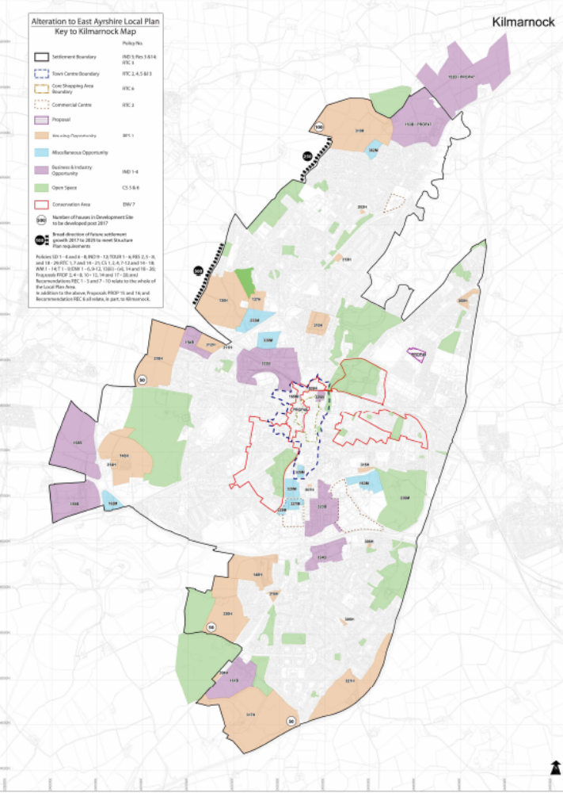
5.5.8 Role of school in community

(i) School lets

In the last three calendar years 27 lets have been organised at Witchhill School. All of these have been for elected member surgeries. Woodstock School has been let on 151 separate occasions since 1 January 2005 until 31 December 2007. Of these lets 43 have been for elected members, 86 have been for the annual Summer School run from Woodstock and 19 have been by the Head Teacher or Parent Council.

(ii) Facilities offered to community

The previous paragraph highlights that there is constant use of facilities within both schools which continue to be used by the community.

(iii) Use of local facilities by the schools

Both schools have very positive relationships with other nearby educational establishments. Woodstock, for example, make use of games hall facilities within Kilmarnock Academy and there are frequent interactions with pupils from other schools.

(iv) Contribution of the schools to local economy

The schools play a vital role in supporting young people and families. Children with complex care needs are educated and cared for during the school day which may allow parents / carers to work.

5.6 Rural Sustainability and Development

Witchhill Special School and Woodstock Special School are both located in the town of Kilmarnock. There are no direct implications arising either from the proposal or from the consultation responses in respect of rural sustainability and development.

5.7 Urban Communities and Regeneration

There were no direct comments received during the consultation process regarding the impact of the proposals on urban communities and regeneration. The retention of a significant special school in the central area of Kilmarnock will have benefits for the children and young people attending the school and for the town.

5.8 Financial Considerations

5.8.1 Respondents recognised that there is considerable financial investment required to bring either school up to a standard fit for modern learning and teaching.

5.8.2 Revenue

In financial year 2006/07 the total net direct spend for the two schools was £764,492. This can be broken down as follows :-

Witchhill Woodstock
£ £
Employee Costs Teachers’ Costs 47,965 327,101
Ancillary Staff 126,941 132,277

Property Costs 19,574 41,386

Transport Costs 2,243 2,251

Supplies 40,584 27,037

School Meal Income (22) (2,845)

237,285 527,207

Work has been undertaken with Financial Services to verify the revenue savings which would be achieved if either options 2 or 3 were accepted by Cabinet. The tables below detail the savings :-

Option 2 :

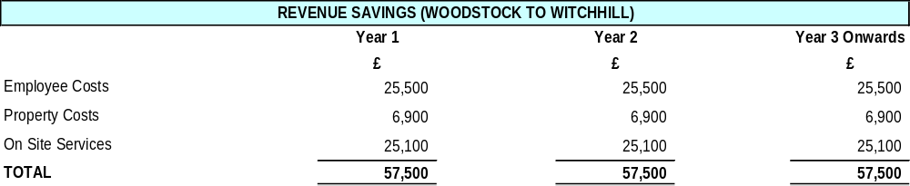

Option 3

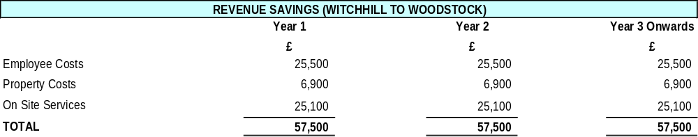

Options 4 – 6 : *

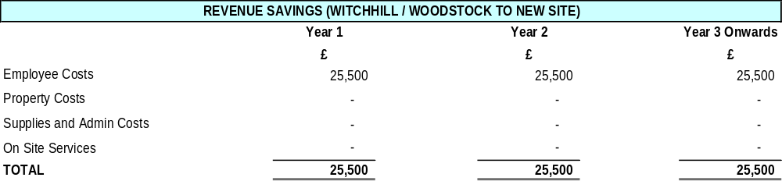

* It should be noted that definitive revenue savings property and Onsite cannot be quantified at this time for a new school sited in a new location. Senior staff cost savings will be similar regardless any preferred decision from options to 2 to 6.

The above tables detail the revenue savings which would be generated for options 2 to 6 of the Consultative Document. Under the Council procedures additional staffing may be allocated to the receiving school to assist with the learning and teaching process during the first two academic sessions following any merger.

In addition to these savings there would also be corporate ICT network savings of approximately £3,000 per annum.

Work with The Strathclyde Partnership for Transport (SPT) has indicated that there should be no increase in transport costs, should the Council pursue any of options 2 to 6.

At its meeting of 7 November 2007, Cabinet agreed that all revenue savings resulting from options 2 to 6 will be reinvested into the Education Service.

5.9 Other Alternatives

5.9.1 One staff member’s response suggested a new shared campus, rather than a new merged school. This has been noted, but has not been a view expressed by other respondents.

5.10 Unique Local Factors

5.10.1 Respondents urged the Council to ensure ongoing consultation and engagement with all stakeholders if the proposals to merge are agreed by Cabinet.

A strong commitment exists to continue to work in partnership with the staff of both schools, the Parent Council of Witchhill School and the Woodstock Parents’ Support Group, colleagues in health and social work services in the development of future educational provision. The Council and its planning partners will ensure that the appropriate mechanisms exist to take this forward.

5.10.2 Many respondents commented on the fragile health of many children attending both special schools. A number of comments received relate to the design of a new build, given the vulnerability of children attending. These comments will be considered, as appropriate, in future discussions.

6. CORPORATE MANAGEMENT TEAM ROLE IN THE CONSULTATION PROCESS

Throughout the consultation process there have been full and regular discussions at the highest level of Officer Management of the Council. The results of these discussions are incorporated into the text of this paper and address all educational and non-educational issues raised in and by the consultative document. The following points identify where joint working within the Council has taken place throughout the process:-

- The recent re-survey work on Witchhill and Woodstock Special Schools has been carried out in conjunction with officers from Technical Services;
- Legal Services have provided specific comments on relevant factors;
- Finance Services have audited and confirmed the potential revenue savings;
- The Community Planning Partnerships Unit have provided specific comment in the body of each Cabinet report;
- Roads have provided estimates of the pupil travelling distances, and professional road safety advice for each of the options listed in the Consultation Documents;
- Planning Services have been involved in the preparation of future pupil rolls, providing data on new housing developments which have been built into the Local Plan.

The outcome of all this involvement and more is a set of recommendations by the Executive Director of Educational and Social Services supported by the Corporate Management Team.

7. THE COUNCIL’S APPROACH TO CONSULTATION

7.1 The forgoing subsections of paragraph 5 above detail the Council’s considerations of all issues as originally defined in the consultation documents and importantly, all of these, both educational and non-educational raised through the detailed consultation responses. The Council allocated well beyond the statutory minimum (28 days) consultation period for responses (giving 54 days) in recognition of the significance with which the intended parties/stakeholders regard this matter.

7.2 Of the 51 responses, some very detailed, no issue raised remains unaddressed and so Cabinet has before it in this paper, full and detailed arguments for and against the options (1, 2 and 3) as set out for consultation.

8. RISK MANAGEMENT

8.1 Any reduction in the property portfolio will reduce the risk to which the Council is exposed in terms of issues such as infrastructure failure, vandalism and threats to security. Any property that is vacated, however, is likely to be exposed to an increased level of risk requiring additional security measures.

9. LEGAL ISSUES

9.1 By virtue of s22 (1) of the Education (Scotland) Act 1980 the Council may discontinue or change the site of, any educational establishment under its management. However prior to any such decision the Council is required to consult in terms of the Education (Publication and Consultation etc. (Scotland) Regulations 1981 which consultation forms the subject matter of this report. It is a legal requirement that the Council shall not reach any decision without having regard to any representations made in response to the consultation. Consequently members require to consider the consultation representations fairly.

9.2 As provided for in s1 of the 1980 Act it is the duty of the Council to ensure adequate and efficient provision of school education within East Ayrshire such education to be directed towards the development of the personality, talents and mental and physical abilities of children or young persons to their fullest potential (Standards in Scotland’s Schools Etc. Act 2000 s2). That said, as with all Council duties, the Council has a duty to make arrangements to secure best value and in securing best value the Council is required to maintain an appropriate balance between, inter alia, the quality of its performance of its functions and the cost to the authority of that performance (Local Government in Scotland Act 2003 s1). In coming to any decision members should balance the foregoing duties.

9.3 Article 2 of the first protocol to the European Convention on Human Rights, incorporated into domestic law by the Human Rights Act 1998 provides that “No person shall be denied the right to education. In the exercise of any functions which it assumes in relation to education and to teaching, the State shall respect the right of parents to ensure such education and teaching in conformity with their own religious and philosophical convictions” The principle in the second sentence is accepted into UK law only so far as it is compatible with the provisions of efficient instruction and training, and the avoidance of unreasonable public expenditure. The right to education is a general right and the relevant provisions of the 1980 Act and the Standards in Scotland’s Schools etc (Scotland) Act 2000 go beyond what is required by the provision in the first protocol. Accordingly provided the Council complies with the duties referred to in para 9.2 a successful Human Rights challenge to a properly considered decision is most unlikely.

9.4 Extremely useful guidance on how Council’s should handle decisions relating to the School Estate (“Additional Guidance on Local Authority Proposals for the School Estate, Including School Closures) was issued by the Scottish Executive in 2004 and reissued again last year. The guidance has been taken into account in the drafting of this report however it is also recommended that members familiarise themselves with the guidance. It would be too simplistic to attempt to summarise the guidance which is to be read as a whole but some of the principle issues are the following. A number of possible relevant factors are identified in the guidance which the Council must have regard to but in the event of a decision being finely balanced, the quality of education provided to pupils, locally and more widely, now and in the future, will normally be the overarching consideration. Consequently this report outlines, and members must consider, the educational advantages of the proposal. Indeed the Cabinet Secretary for Education and Lifelong Learning has indicated that in cases which are referred to the Scottish Government for consent she will be asking HMIE for advice on the case presented and on the envisaged educational advantages the proposal is intended to secure. Further the educational advantages must be both local and on the wider scale.

9.5 By virtue of the said 1981 regulations any proposal which would result in primary pupils having to attend an alternative school 5 or more miles distant from their current school or where the school’s role is greater than 80% of capacity requires the consent of the Scottish Ministers. As neither situation arises the recommendation, if approved, will not require to be referred for Ministerial consent.

9.6 Title Implications

9.6.1 Witchhill School

There are no subsisting title conditions restricting the use of the site. Should the recommendation be followed and the site declared surplus to requirements the Council could dispose of the site.

9.6.2 Woodstock School

The Council’s title contains a use restriction restricting the use of the site to school purposes .That use restriction given that it was contained in a Feu Disposition as opposed to a disposition ceased to subsist or be enforceable by the former superior as a title condition with effect from 28th November 2004 in terms of the Abolition of Feudal Tenure (Scotland) Act 2000. Whilst the 2000 Act did not impact on the rights of adjacent property owners to enforce conditions contained within a feu writ it is however considered given the nature of the use restriction that there are no third parties with a potentially subsisting or enforceable title condition.
Section 75 of the Abolition of Feudal Tenure (Scotland) Act 2000 however further preserves the rights of the granter of the original title or their assignees as superiors on 28th November 2004 to enforce the use restriction as a matter of contract as opposed to a matter of title. There has been a number of changes in ownership of the superiority interest since the date of grant of the Council’s title in 1876 and as no formal assignation of the right to enforce the title obligations in terms of contract appears to have been granted, it is considered that the contractual obligation does not subsist. Therefore, should the recommendation be followed and the site be declared surplus to requirements the Council could dispose of the site.

10. CONCLUSION

10.1 Having carefully considered the responses made during the consultation period, and placed these alongside the current condition of the fabric of the existing Witchhill and Woodstock School buildings, it is concluded that the original proposals remain valid.

10.2 In summary, Option 4 is preferred which will result in the closure of both existing schools in June 2009, or as soon as possible thereafter, resulting in a new school from the merger. Further it is the transfer of pupils to a new school sited on the existing Park School site in August 2009, or as soon as possible thereafter, which will secure the greatest educational and welfare advantages for young people, for the reasons listed in paragraph 6.4 (above).

11. RECOMMENDATIONS

11.1 Taking account of all the issues raised in consultation, it is recommended that the Cabinet agree that:

- Witchhill and Woodstock Schools be closed with effect from the end of the school session June 2009, or as soon as possible thereafter;

- A new school results from the merger of the schools and that the pupils will transfer to this new school facility on the current Park School site, in August 2009, or as soon as possible thereafter;

iii) The Executive Director of Educational and Social Services conducts a consultation exercise in due course to determine a name for the new school and report in due course;

iv) The Executive Director of Educational and Social Services declares the existing buildings and land on both Woodstock and Witchhill school sites surplus to educational requirements in August 2009, or as soon as possible thereafter, and remits the matter to the Executive Head of Finance and Asset Management for disposal;

v) The Executive Director of Educational and Social Services ensures effective procedures for continued consultation with all relevant stakeholders to inform them of how the matter will be progressed; and

vi) Otherwise note the contents of this report.

Graham Short
Executive Director of Educational and Social Services

GRS/EC/MR

LIST OF BACKGROUND PAPERS

- Written responses to the consultation document
- Cabinet Secretary’s Guidance issued to education authorities

Members wishing further information should contact Graham Short, Executive Director of Educational and Social Services, Telephone (01563) 576017.
APPENDIX 1

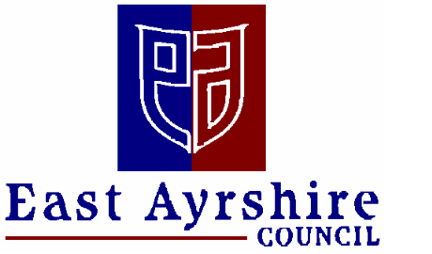

DEPARTMENT OF EDUCATIONAL & SOCIAL SERVICES

THIS IS A CONSULTATIVE DOCUMENT

SPECIAL EDUCATION AT WITCHHILL AND WOODSTOCK SCHOOLS

The following schools are affected by this Consultative Document:

- Woodstock School
- Witchhill School

This document has been issued by East Ayrshire Council’s Executive Cabinet for
consultation in terms of the Education (Publications and Consultation etc) (Scotland)
Regulation 1981 and Amendment Regulation 1987, 1988 and 1989.

EAST AYRSHIRE COUNCIL
DEPARTMENT OF EDUCATIONAL & SOCIAL SERVICES

THIS IS A CONSULTATIVE DOCUMENT

Proposal :

That subject to the outcome of this consultation exercise:-

- Current education provision in the existing Witchhill and Woodstock Schools and their current buildings be discontinued with effect from June 2009, or as soon as possible thereafter.

- Further that the schools should merge and that a new special school be created from the merger.

- Further that the new school be situated in a new or refurbished building to be located in Kilmarnock, in accordance with one of the options set out within this report, as yet to be determined

Report by Executive Director of Educational and Social Services

1. EAST AYRSHIRE COUNCIL’S VISION FOR THE SCHOOL ESTATE

  - East Ayrshire Council has an established vision for its school estate which will ensure the delivery of a modern curriculum in school buildings that are suitable for purpose. This vision further states:

“East Ayrshire Council’s Department of Educational and Social Services: committed to providing choice, maximising opportunity for all, developing the potential of individuals and meeting needs through inclusion”

1.2 This statement covers every aspect of the Department’s work including the management and development of educational establishments. The Council’s 2004 School Estate Management Plan states that development and improvement in the fabric of school buildings is a key component in facilitating the learning and teaching process.

1.3 The Council has also approved the Department’s objectives for achieving its aims. These are as follows:

- to reduce surplus capacity in primary schools;
- to address property maintenance issues;
- to meet statutory requirements of the Disability Discrimination Act (DDA); and
- to improve property flexibility.

1.4 East Ayrshire Council also subscribes to the vision for Scotland’s children as set out in 2004 by The Curriculum Review Group in the document A Curriculum for Excellence, which states that “Our aspiration is to enable all children to develop their capacities as successful learners, confident individuals, responsible citizens and effective contributors to society”.

1.5 The proposals set out in this document will ensure that all these issues are addressed in a manner which will achieve improvements for all the pupils and staff of Woodstock and Witchhill schools, whilst also obtaining best value for the Council.

2 EDUCATIONAL PROVISION AT WOODSTOCK AND WITCHHILL SCHOOLS

2.1 Overview

2.1.1 The buildings occupied respectively by Witchhill and Woodstock schools no longer meet the Council’s vision for its schools’ estate. They do not meet the needs of the pupil population, they are not in good repair, they are not DDA compliant and their design is not best suited to the delivery of the modern school curriculum.

2.2 Witchhill School

2.2.1 Witchhill School provides co-educational, non-denominational education for pupils with profound learning and physical difficulties.

2.2.2 The school has a current pupil roll of 5, as at September 2007.

    - The current school building fabric requires significant refurbishment to bring it up to a standard capable of meeting the complex needs and curricular requirements of pupils. Since 2000 East Ayrshire Council has invested £61,000 in maintenance and improvements at Witchhill School. The total cost of improvement work to bring the school building to a condition consistent with the Council’s vision is estimated to be approximately £611,000. This level of investment would not yield best value for East Ayrshire Council.

  - Woodstock School

2.3.1 Woodstock School provides co-educational and non-denominational education for pupils with profound learning and physical difficulties.

    - The school has a current pupil roll of 29, as at September 2007.

    - The existing school building fabric requires significant refurbishment to bring it up to a standard capable of meeting the complex needs and curricular requirements of pupils. Since 2000 East Ayrshire Council has invested £169,000 in maintenance and improvements at Woodstock School. The total cost of improvement work to bring the school building to a condition consistent with the Council’s vision is estimated to be approximately £670,000. This level of investment would not yield best value for East Ayrshire Council.

2.4 Educational issues

2.4.1 Despite the shortcomings of the accommodation, the management and staff at both establishments have worked tirelessly since 1996 to ensure that the pupils attending these schools receive the best possible educational experience and the highest standard of care.

    - However, this effort is being expended in the face of increasing pressure. The unsuitability of the accommodation affects learning and teaching. The reducing numbers in attendance at Witchhill School means that staff deployment is not as effective as it might be and the small size, does nothing to enhance social aspects of pupils’ educational development. Woodstock School, on the other hand, levels adequate and suitable space to meet the needs of its young people to a satisfactory standard.

3. THE PROPOSAL

3.1 It is for the reasons outlined in section 2.1 to 2.4 (above) that East Ayrshire Council wishes to consult on the proposal to discontinue educational provision at Witchhill and Woodstock Schools and to merge these schools to create one fit-for-purpose special needs establishment at a suitable location in Kilmarnock.

4. OPTIONS FOR THE CONTINUING EDUCATION OF PUPILS CURRENTLY ATTENDING WITCHHILL AND WOODSTOCK SCHOOLS

4.1 In addition to receiving comment on the proposal the Council wishes to receive feedback on site options for a new school as outlined below. Comments on the identification of other suitable sites are also welcome.

4.2 Option 1 – Status Quo: maintain both schools as they currently exist

4.2.1 If approved this option would result in the two schools being maintained as separate educational establishments, being located within their present accommodation.

    - Benefits

- would provide continuity with no disruption to pupils’ current educational experience.

    - Issues to consider:

- both buildings are presently unfit for purpose;
- refurbishment of both buildings would not represent best value;
- ongoing property costs for both buildings would not represent best value;
- even if refurbished, the basic design of these buildings is less than ideal;
- pupils would lose out on the opportunity to be educated in a modern, state-of-the-art school building;
- decreasing numbers of pupils receiving non-inclusive education would mean that the roll of both schools would continue to fall and long-term sustainability would be an issue.

4.3 Option 2 – Locate a merged school on the current Witchhill site

4.3.1 Benefits:

- the school would be situated centrally in Kilmarnock;
- the site is already known as the location of a special school and is close to the location of the present Woodstock School;
- some children are familiar with the current location and accommodation;
- existing buildings could be refurbished and extended, thereby reducing the cost of the merger and the timescale for completion;
- merger of the two schools would bring together the best of each in terms of resources and talents.

    - Issues to consider:

- refurbishment would cause difficulties in terms of ongoing service delivery for the pupils currently attending Witchhill School;
- the site of the school is cramped and would restrict design options for the refurbished school.

  - Option 3 – Locate merged school on the current Woodstock site

    - Benefits:

- the school would be situated centrally in Kilmarnock;
- the site is already known as the location of a special school and is close to the location of the present Witchhill School;
- some children are familiar with the current location and accommodation;
- existing buildings could be refurbished and extended, thereby reducing the cost of the merger and the timescale for completion:
- merger of the two schools would bring together the best of each in terms of resources and talents.

    - Issues to consider:

- any refurbishment would cause difficulties in terms of ongoing service delivery for the pupils currently attending Woodstock School;
- the site of the school is cramped and would restrict design options for the refurbished school.

  - Option 4 - Locate merged school on the site of the present Park School

    - Benefits:

- the school would be situated centrally in Kilmarnock;
- the site is already known as the location of a special needs school;
- the new school would be close to the new St. Joseph’s campus on Grassyards Road and Kilmarnock College and therefore to the facilities located at these establishments;
- a new school would allow for specialist facilities to be created without any disruption to pupils’ current routine in either establishment;
- a new build would feature state-of-the-art facilities, design and technology;
- the site curtilage provides more than sufficient space for the development;
- merger of the two schools would bring together the best of each in terms of resources and talents.

    - Issues to consider:

- the site is located on a main road which would require traffic management;
- pupils would be unfamiliar with this site.

  - Option 5 - Locate merged school on the site of the present St. Matthew’s Primary School

    - Benefits:

- the school would be situated relatively centrally in Kilmarnock;
- the new school would be relatively close to the new St. Joseph’s campus on Grassyards Road and Kilmarnock College and therefore to the facilities located at these establishments;
- a new school would allow for specialist facilities to be created without any disruption to pupils’ current routine in either establishment;
- a new build would feature state-of-the-art facilities, design and technology;
- the site curtilage provides more than sufficient space for the development;
- merger of the two schools would bring together the best of each in terms of resources and talents.

    - Issues to consider:

- the site would require to be spilt creating a special school and ground for other use;
- pupils would not be familiar with this site;
- the school would be further out from the centre of Kilmarnock than existing or alternative sites.

  - Option 6 - Locate merged school on a site to be identified in the Kilmarnock area

    - Benefits:

- a new school would allow for specialist facilities to be created without any disruption to pupils’ current routine in either establishment;
- the site could be chosen to ensure the optimum benefit for pupils;
- a new build would feature state-of-the-art facilities, design and technology;
- merger of the two schools would bring together the best of each in terms of resources and talents.

    - Issues to consider:

- if not in Council ownership the purchase of land would require negotiation and would increase the overall cost of the project;
- pupils would not be familiar with this site;
- a suitable site may not be available for development in the desired timescale.

5. IMPLICATIONS

5.1 Staffing Implications

5.1.1 The proposal as outlined in Section 3 would have implications for teaching and ancillary staff in the schools affected. Whilst there would eventually be staffing reductions in terms of the combined total of staff at the two existing schools, this will be achieved without compulsory redundancies. It would also be achieved without compromising the staffing standard, the ratio of staff to pupils. Pupils would have exactly the same or better level of support, geared to their individual needs, as at present.

5.1.2 All members of staff would be fully consulted about their future as would the appropriate trade unions representing all grades of staff affected. The particular wishes of each member of staff would be taken into consideration.

5.1.3 If any of Options 2 – 6 is chosen, the merged school would be entitled to a staffing enhancement for a period of upto two years, in order to ease the transition. The school would also receive additional clerical support and resources over this period.

5.2 Financial Implications

5.2.1 Staffing costs, property costs, the costs associated with the provision of supplies and services, janitation and cleaning costs and administration costs would be very significantly reduced by the merger of the two schools.

5.2.2 Further savings would accrue from the reduction from two establishments to one and from the fact that the new building would be ‘greener’ more energy efficient and requiring less maintenance. In addition, experience has shown that the increased security of new buildings makes them less vulnerable to break-ins and vandalism.

5.2.3 If the proposals for a merged Special School are accepted and in accordance with current Council policy, all the funds realised from the sale of either or both sites would be used to enhance educational provision.

5.3 Transport implications

5.3.1 Transport for all pupils attending the new, relocated school would be provided in line with Council policy. The current policy is to provide free transport for all pupils who attend special schools.

    - A key part of the development will be the management of transport in the school vicinity and this will include the highest possible standards for safe pupil transport.

  - Name of new school

5.4.1 If any of the Options 2 - 6 is chosen, a further consultation exercise will be undertaken to choose a name for the new merged school.

6. RECOMMENDATIONS

6.1 It is recommended that the Cabinet agree to adopt for the purpose of consultation the proposal that:-

i) That subject to the outcome of this consultation exercise:-

- Current education provision at the existing Witchhill and Woodstock Schools and their current buildings be discontinued with effect from June 2009, or as soon as possible thereafter.

- Further that the schools should merge and that a new special school be created from the merger.

- Further that the new school be situated in a new or refurbished building to be located in Kilmarnock, in accordance with one of the options set out within this report, as yet to be determined

  - It is also recommended that :-

i) interested parties be invited to make written or electronic submissions on the proposal to the following addresses :-

By post :Executive Director of Educational & Social Services, East Ayrshire Council, Council Headquarters, London Road, Kilmarnock KA3 7BU.

By e-mail: educationconsultation@east-ayrshire.gov.uk

Written submissions should be returned no later than Monday 21 January 2008.

ii) the Executive Director of Educational & Social Services prepare a report on the results of the consultative process for consideration at a future meeting of the Cabinet

Graham Short
Executive Director of Educational and Social Services

It was not entirely clear, in one or two instances, in what capacity the respondent was writing.

