Photographs of Witchhill School and the School Grounds

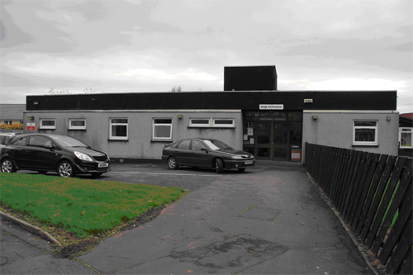

Photograph 1 : Front elevation.

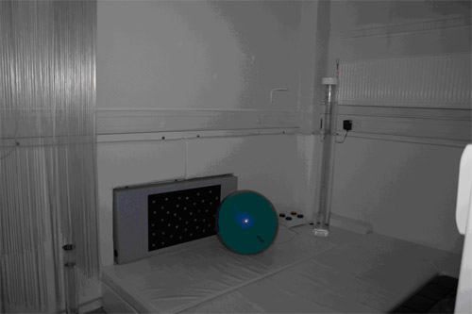

Photograph 2 : Sensory equipment

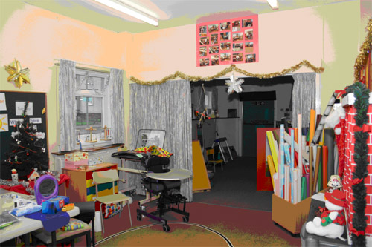

Photograph 3 : Teaching area

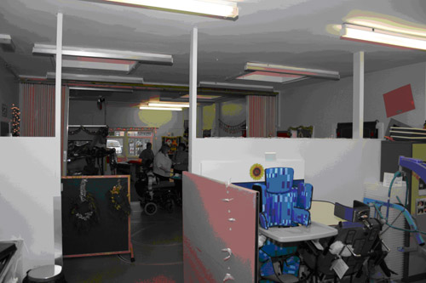

Photograph 4 : Teaching area

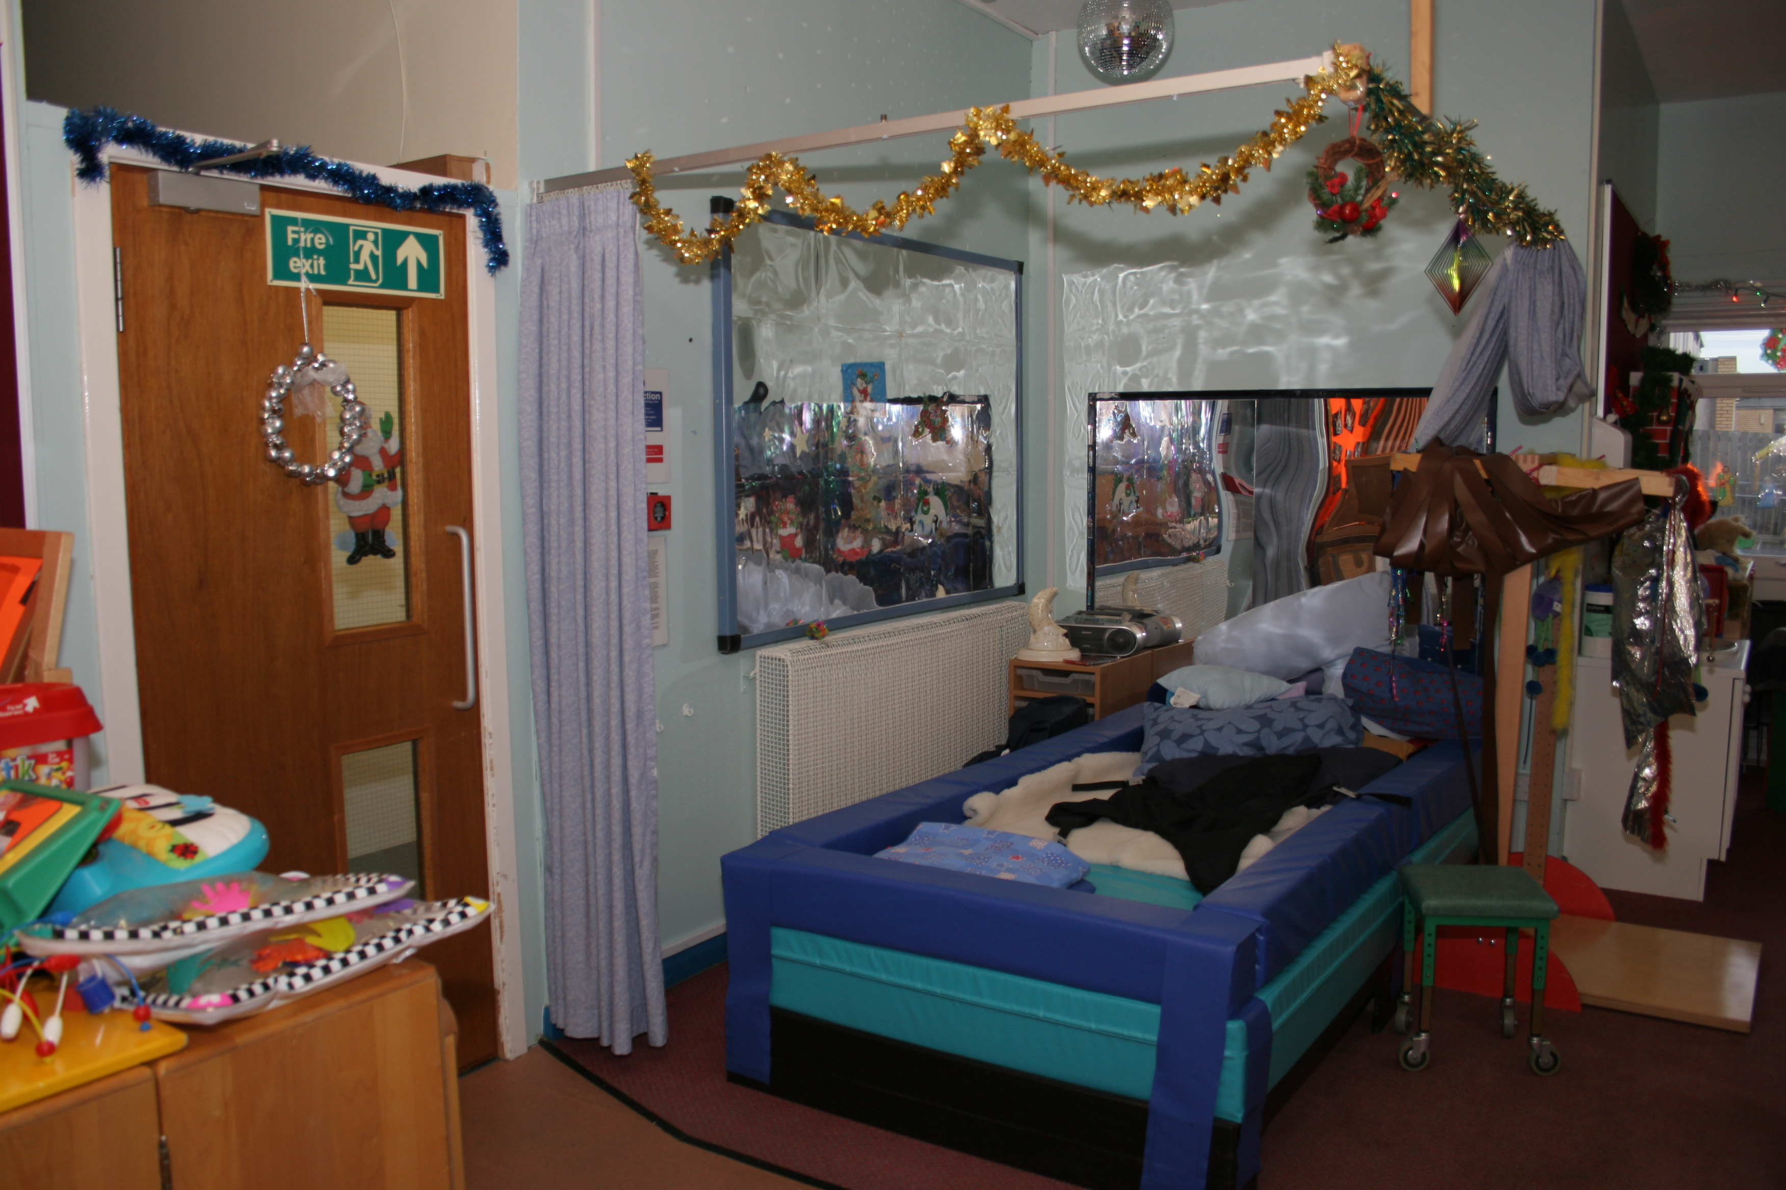

Photograph 5 : Sensory equipment

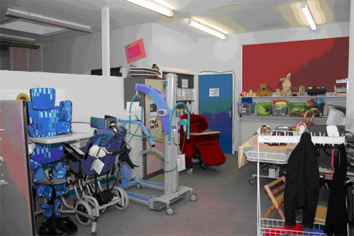

Photograph 6 : Flexible equipment

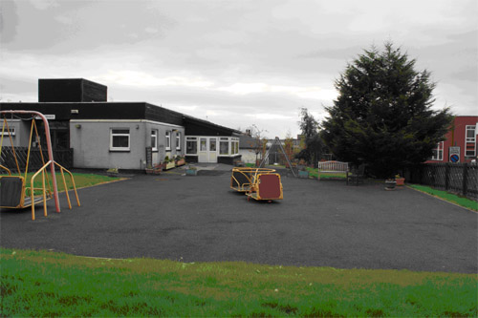

Photograph 7 : The play area.

Photographs of Woodstock School and the School Grounds

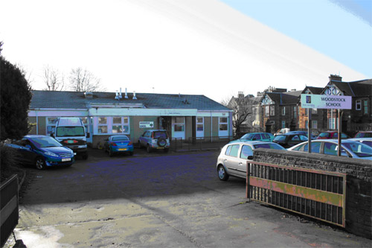

Photograph 1 : The front elevation

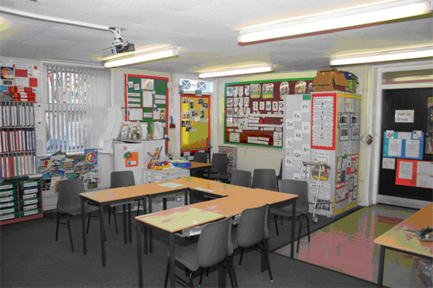

Photograph 2 : Classroom

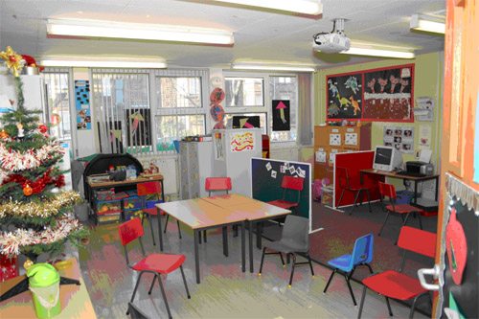

Photograph 3 : Classroom
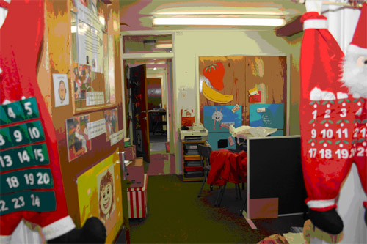

Photograph 4 : Classroom

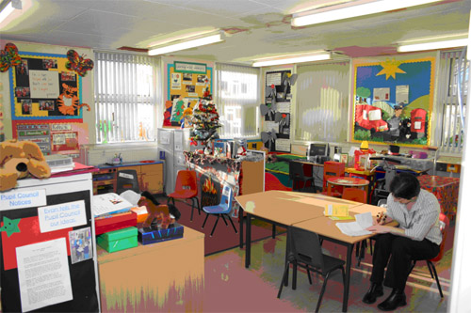

Photograph 5 : Classroom
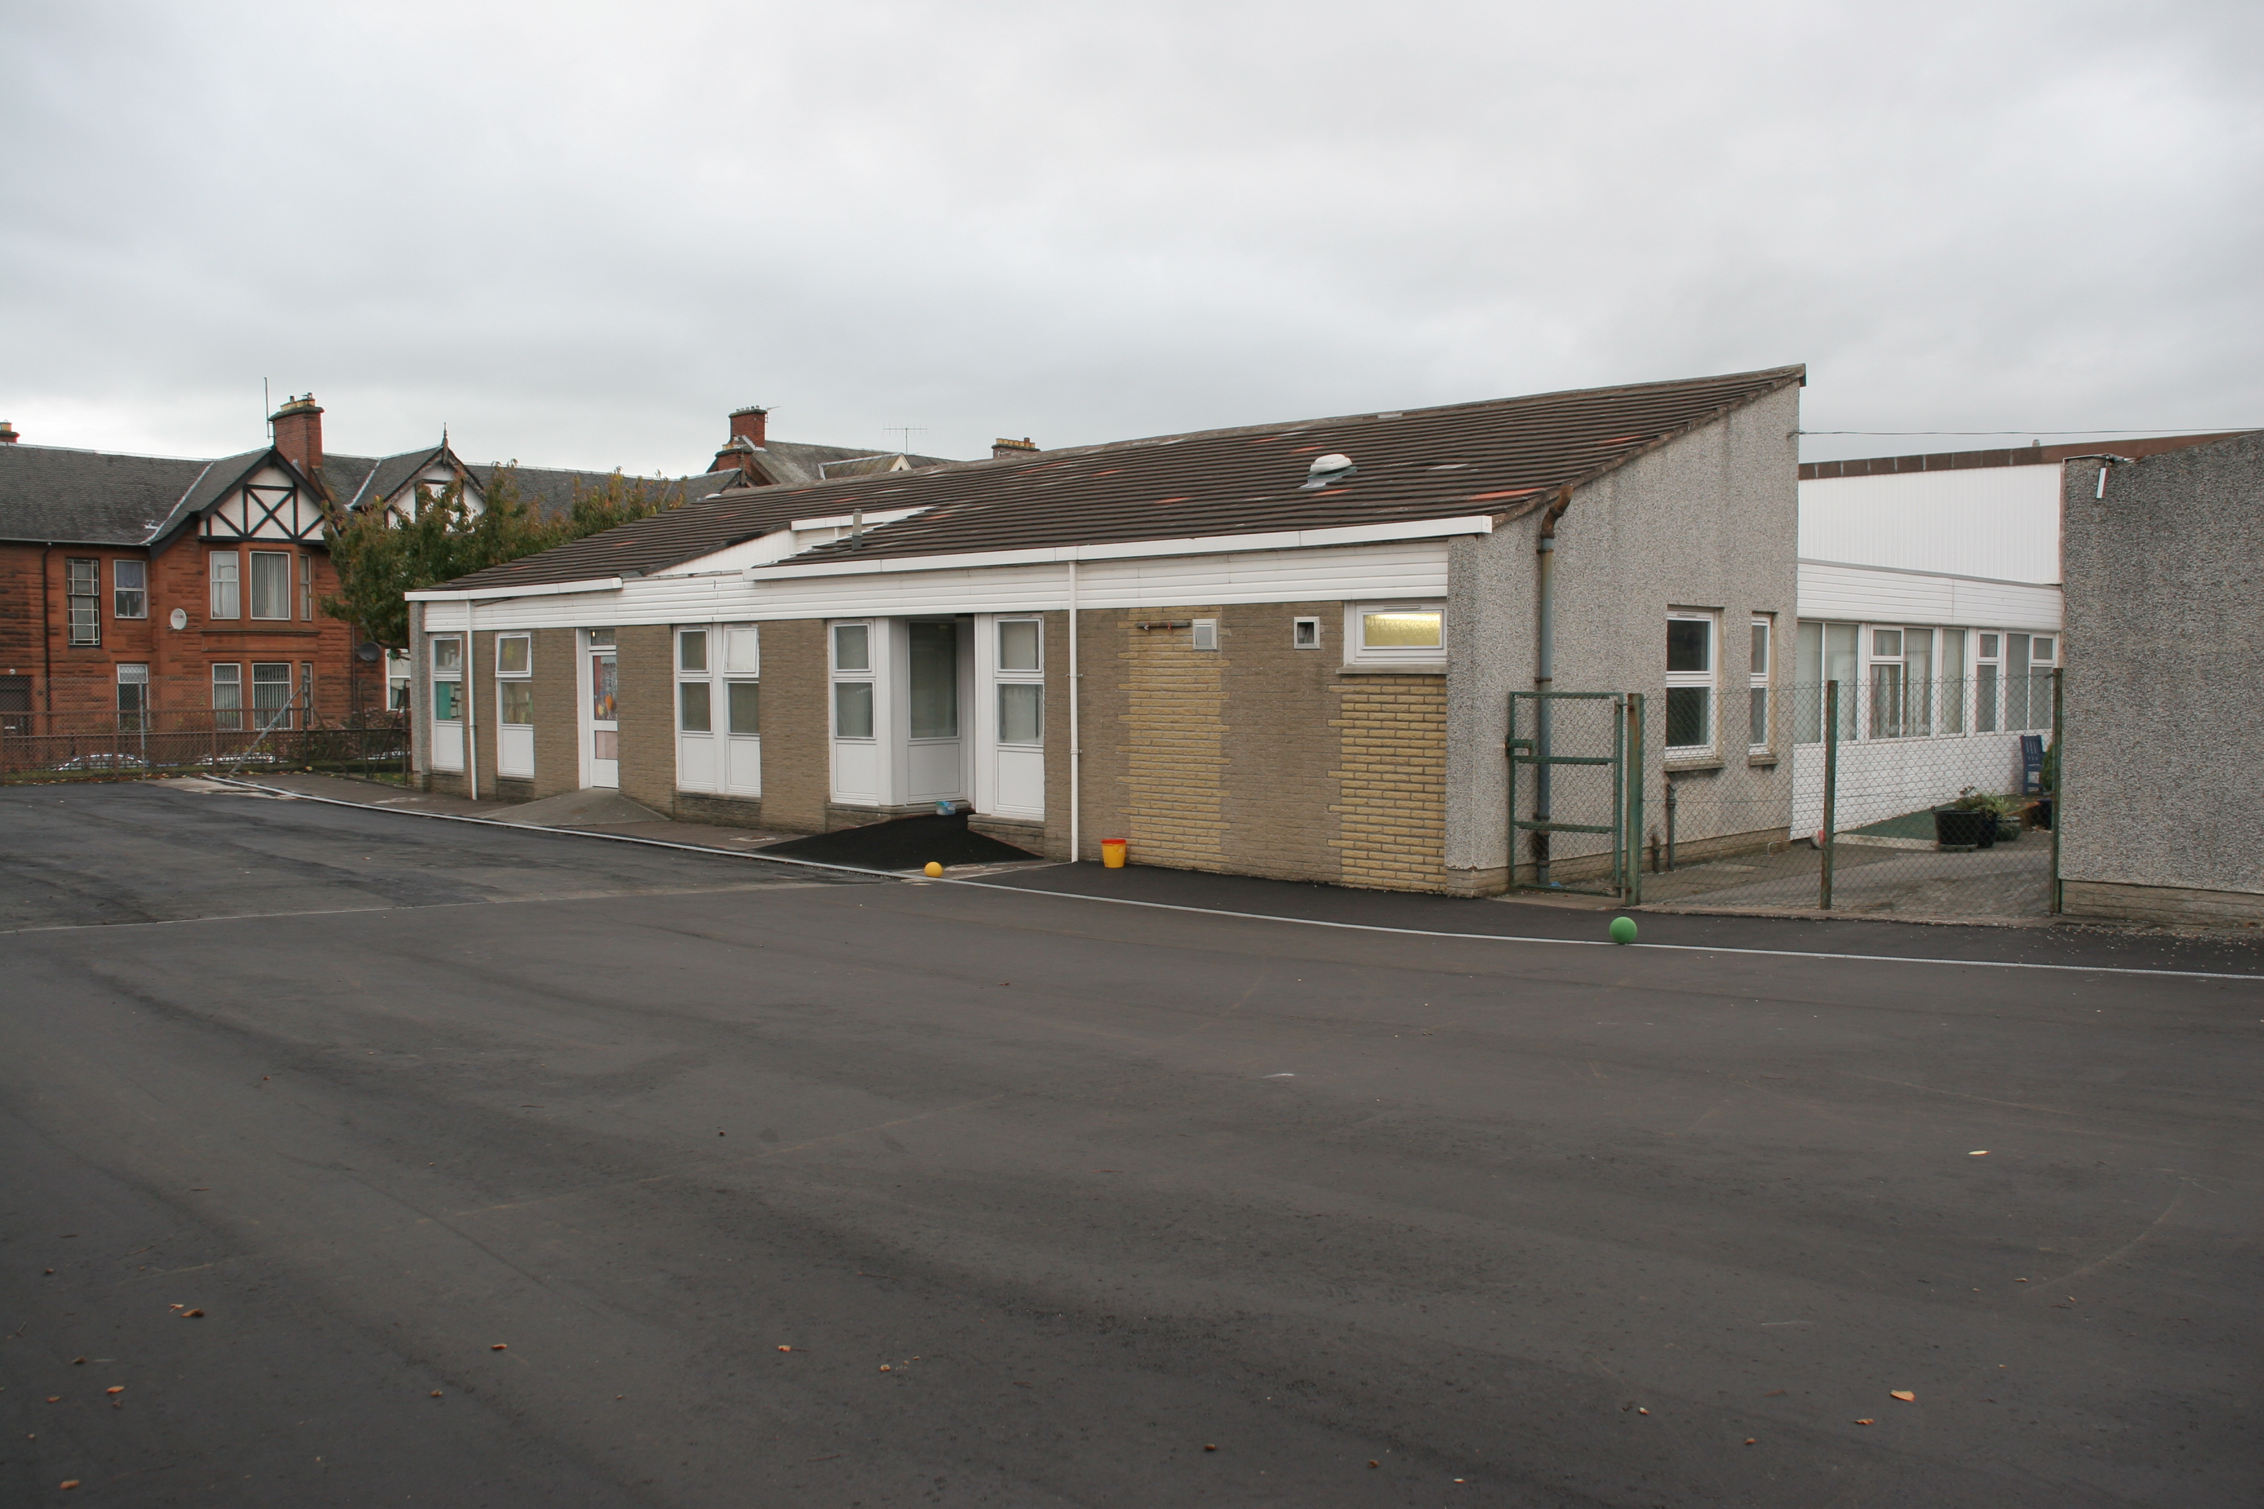

Photograph 6 : Playground area

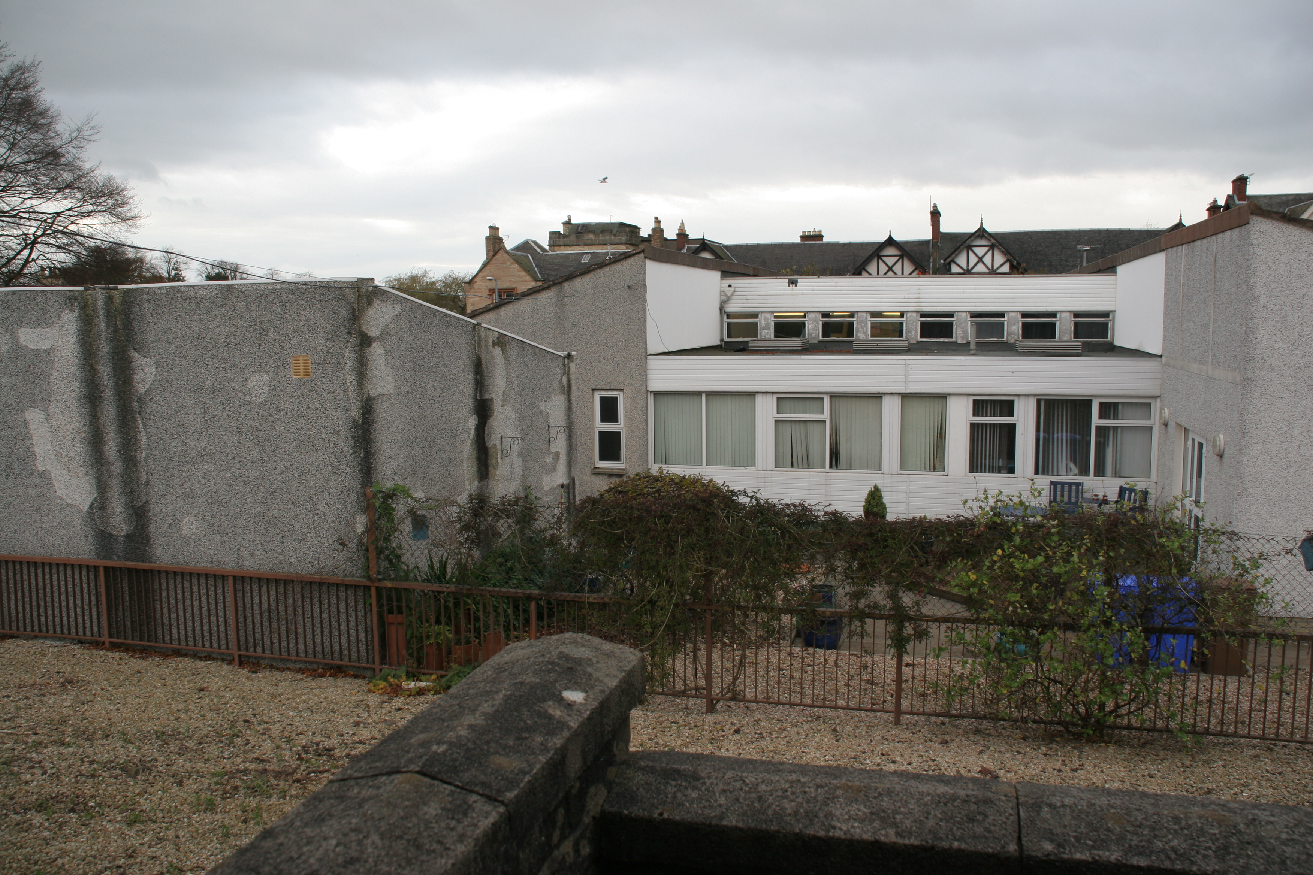

Photograph 7 : Rear Elevation

