2.5 E

EAST AYRSHIRE COUNCIL

DEPARTMENT OF EDUCATIONAL AND SOCIAL SERVICES

THE RESULT OF THE CONSULTATION ON THE PROPOSAL TO:

- CURRENT EDUCATION PROVISION IN THE EXISTING ST XAVIER’S PRIMARY SCHOOL BUILDING BE DISCONTINUED WITH EFFECT FROM JUNE 2008, OR AS SOON AS POSSIBLE THEREAFTER.
- FURTHER, THAT ALTERNATIVE ARRANGEMENTS BE MADE FOR THE FUTURE EDUCATION OF THE ST XAVIER’S PUPILS FROM AUGUST 2008 OR AS SOON AS POSSIBLE THEREAFTER, IN ACCORDANCE WITH THE RECOMMENDATIONS SET OUT WITHIN THIS REPORT.

APPENDIX 1 - THE CONSULTATIVE DOCUMENT

WRITTEN SUBMISSIONS FROM INTERESTED PARTIES ON THE CONSULTATIVE PROCESS ARE AVAILABLE FOR INSPECTION IN THE MEMBERS’ INFORMATION POINT.
CONTENTS

1. INTRODUCTION

2. ST XAVIER’S PRIMARY SCHOOL

  - Catchment Area Map

  - Accommodation and Capacity

  - School Layout and Photographs of St Xavier’s Primary School Building

  - Building Condition

2.5 School Information

3. THE CONSULTATION

4. RESPONSES TO THE CONSULTATION

Public Meeting
Written Responses - Parent Council
Pupil Council
MSP and Local Councillor
Individual Pupils etc
Individual Parents etc
Diocese of Galloway
Other Interested Parties

5. COMMENTS ON THE VIEWS EXPRESSED

5.1 Introduction

5.2 The Educational Case

5.3 Travel Distances and Times

5.4 Future Pupil and Population Projections

5.5 Community Planning and Use

5.6 Rural Sustainability and Development

5.7 Urban Communities and Regeneration

5.8 Financial Considerations

5.9 Other Alternatives

5.10 Unique Local Factors

6. CORPORATE MANAGEMENT TEAM ROLE IN THE CONSULTATION PROCESS

7. THE COUNCIL’S APPROACH TO CONSULTATION

8. RISK MANAGEMENT

9. LEGAL ISSUES

10. CONCLUSION

11. RECOMMENDATIONS

EAST AYRSHIRE COUNCIL

DEPARTMENT OF EDUCATIONAL AND SOCIAL SERVICES

THE RESULT OF THE CONSULTATION ON THE PROPOSAL TO
- CURRENT EDUCATION PROVISION IN THE EXISTING ST XAVIER’S PRIMARY SCHOOL BUILDING BE DISCONTINUED WITH EFFECT FROM JUNE 2008, OR AS SOON AS POSSIBLE THEREAFTER.
- FURTHER, THAT ALTERNATIVE ARRANGEMENTS BE MADE FOR THE FUTURE EDUCATION OF THE ST XAVIER’S PUPILS FROM AUGUST 2008 OR AS SOON AS POSSIBLE THEREAFTER, IN ACCORDANCE WITH THE RECOMMENDATIONS SET OUT WITHIN THIS REPORT.

Report by the Executive Director of Educational and Social Services

- INTRODUCTION

1.1 The purpose of this report is to set out the views expressed and the issues raised resulting from the public consultation exercise on the future of St. Xavier’s Primary School.

1.2 On 7 November 2008 East Ayrshire Council’s Cabinet approved the issue of a consultative document which proposed the relocation or closure of St Xavier’s Primary School. A copy of the consultative document is attached as Appendix 1.

1.3 The main issues raised in the consultative document were:-

- The need for multi composite classes in smaller schools;
- Resource management in smaller schools with multi composite classes;
- The limited interaction with other pupils of a similar age and a reduction in the breadth of the curriculum;
- The difficulty in retaining and recruiting staff in smaller rural schools;
- The building’s inability to deliver a modern curriculum, which is increasingly based on ICT.
- The condition of the fabric of the school building.

1.4 The Consultative Document, approved by Cabinet, offered a range of options open to public consideration. The options listed for St Xavier’s Primary were:

- The status quo : retain St. Xavier’s Primary in its current location;
- Locate the school as a separate establishment within surplus accommodation at Bellsbank Primary School;
- Locate the school as a separate establishment within surplus accommodation at Patna Primary School; and
- Close St Xavier’s Primary School and transfer all pupils to St Ann’s Primary School, Annbank, South Ayrshire Council.

2. ST. XAVIER’S PRIMARY SCHOOL

2.1 Catchment Area

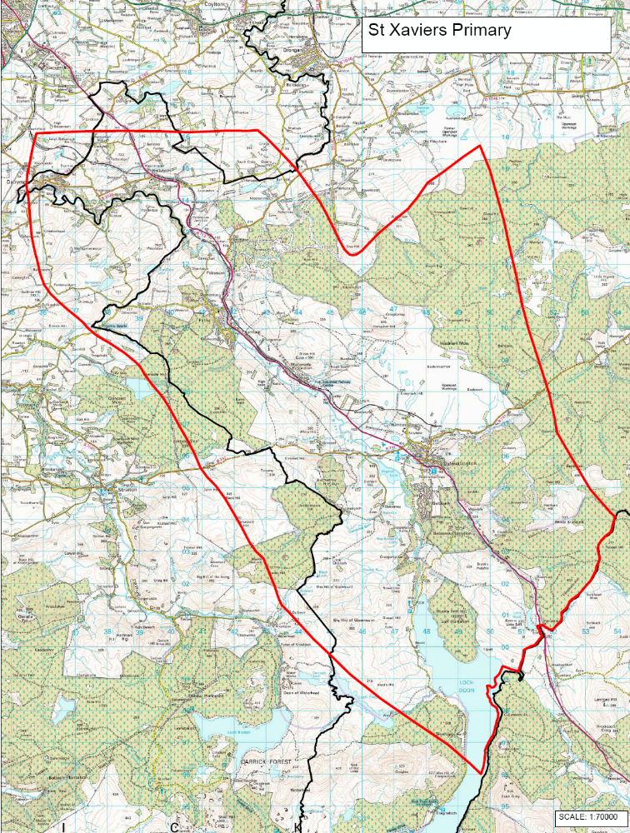
2.2 Accommodation and Capacity

2.2.1 Opened in 1890, St. Xavier’s Primary consists of 4 teaching rooms and a supplementary area for general purpose activities. There is also a pre-fabricated hall used for physical education and other uses which is external to the main building. Within the school is a kitchen and dining hall. Office accommodation is also available for the Head Teacher and there is also a staffroom.

2.2.2 The planning capacity of a school is calculated by dividing the total area of teaching rooms by the space allocation per child (1.7m² in a closed classroom). The working capacity takes account of maximum class sizes, for example, composite classes which are limited to 25. Based on the Council’s space allocation the classrooms could accommodate 132 pupils, however due to maximum class sizes for composite classes the capacity of these rooms is limited to 25 each. Therefore the planning capacity of the school is 132, with a working capacity of 116. The current pupil roll is 40 and the level of occupancy is therefore 30.3%.

The school structure presently has 2 classes made up as follows :-

Primary 1/2/3 and Primary 4/5/6/7.
2.3 School Layout and Photographs

2.3.1 Outline of St. Xavier’s Primary School building and the school grounds



