2.6 E

EAST AYRSHIRE COUNCIL

DEPARTMENT OF EDUCATIONAL AND SOCIAL SERVICES

THE RESULT OF THE CONSULTATION ON THE PROPOSAL that:

- CURRENT EDUCATION PROVISION IN SORN PRIMARY SCHOOL AND ITS EXISTING BUILDING BE DISCONTINUED WITH EFFECT FROM JUNE 2008, OR AS SOON AS POSSIBLE THEREAFTER.

- FURTHER THAT THE FUTURE PRIMARY EDUCATIONAL PROVISION FOR PUPILS CURRENTLY ATTENDING SORN PRIMARY SCHOOL SHOULD BE DETERMINED BY THE COUNCIL IN ACCORDANCE WITH the recommendations set out in this report.

APPENDIX 1- THE CONSULTATIVE DOCUMENT

WRITTEN SUBMISSIONS FROM INTERESTED PARTIES ON THE CONSULTATIVE PROCESS ARE AVAILABLE FOR INSPECTION IN THE MEMBER’S INFORMATION POINT.
CONTENTS

1. INTRODUCTION

2. SORN PRIMARY SCHOOL

  - Catchment Area Map

  - Accommodation and Capacity

  - School Layout and Photographs

  - Building Condition

2.5 School Information

3. THE CONSULTATION

4. RESPONSES TO THE CONSULTATION

(Public Meeting)
(Written Responses - Parent Council
Pupil Council
MSP
Individual Pupils etc
Individual Parents etc
Community Groups
Staff from the School
Staff from Primary Schools Affected
Other Interested Individuals
Other Interested Parties)

5. COMMENTS ON THE VIEWS EXPRESSED

5.1 Consultation Process

5.2 The Educational Case

5.3 Travel Distances and Times

5.4 Future Pupil and Population Projections

5.5 Community Planning and Use

5.6 Rural Sustainability and Development

5.7 Urban Communities and Regeneration

5.8 Financial Considerations

5.9 Other Alternatives

5.10 Unique Local Factors

6. CORPORATE MANAGEMENT TEAM ROLE IN THE CONSULTATION PROCESS

7. THE COUNCIL’S APPROACH TO CONSULTATION

8. RISK MANAGEMENT

9. LEGAL ISSUES

10. CONCLUSION

11. RECOMMENDATIONS

EAST AYRSHIRE COUNCIL

DEPARTMENT OF EDUCATIONAL AND SOCIAL SERVICES

THE RESULT OF THE CONSULTATION ON THE PROPOSAL THAT:

- CURRENT EDUCATION PROVISION IN SORN PRIMARY SCHOOL AND ITS EXISTING BUILDING BE DISCONTINUED WITH EFFECT FROM JUNE 2008, OR AS SOON AS POSSIBLE THEREAFTER.

- FURTHER THAT THE FUTURE PRIMARY EDUCATIONAL PROVISION FOR PUPILS CURRENTLY ATTENDING SORN PRIMARY SCHOOL SHOULD BE DETERMINED BY THE COUNCIL IN ACCORDANCE WITH THE RECOMMENDATIONS SET OUT IN THIS REPORT.

Report by the Executive Director of Educational and Social Services

- INTRODUCTION

1.1 The purpose of this report is to set out the views expressed and the issues raised resulting from the public consultation exercise on the future of Sorn Primary School and to recommend accordingly.

1.2 On the 7 November 2007, East Ayrshire Council’s Cabinet approved the issue of a consultation document which proposed that:

- Current education provision in Sorn Primary School and its existing building be discontinued with effect from June 2008, or as soon as possible thereafter.

- Further that the Sorn Primary School pupils continue their primary school education at another establishment, in accordance with one of the options set out within the report, as yet to be determined.

A copy of the consultative document is attached as Appendix 1.

1.3 The main issues raised in the consultative document were:

- The need for multi composite classes in smaller schools;
- Resource management in smaller schools with multi composite classes;
- The potential for limited interaction with other pupils of a similar age and a reduction in the breadth of the curriculum;
- The apparent difficulty in retaining and recruiting staff in smaller rural schools;
- Serious building deficiencies limit the ability to deliver a modern curriculum, including those increasing elements dependent on ICT.

1.4 The Consultative Document, approved by Cabinet, offered a range of options open to public consideration. The options listed for Sorn Primary were :-

- Option 1 - The status quo : retain Sorn Primary;
- Option 2 - Close Sorn Primary and transfer the pupils to Catrine Primary; and
- Option 3 - Close Sorn Primary and transfer the pupils to Mauchline Primary.

2. SORN PRIMARY SCHOOL
2.1 Catchment Area

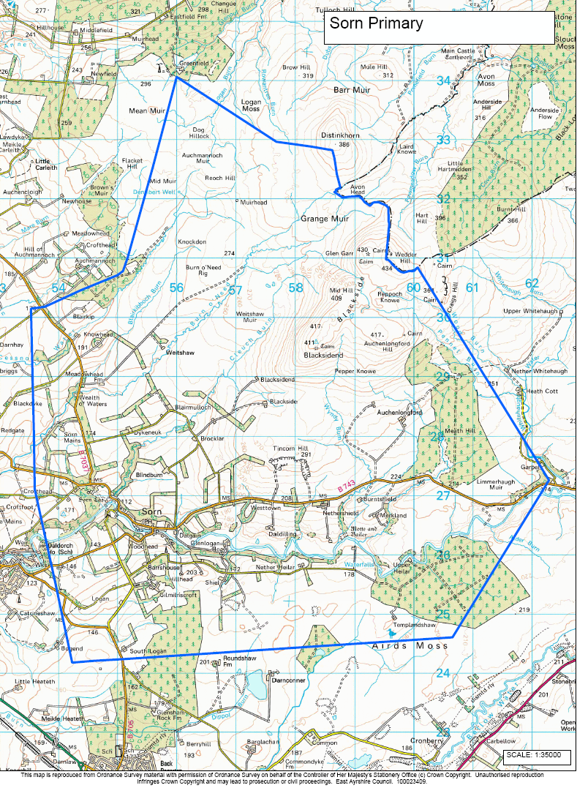

2.2 Accommodation and Capacity

2.2.1 Constructed in the 1850’s, Sorn Primary consists of 4 teaching rooms. There are no General Purpose areas within the building. Also located within the building is office accommodation for the Head Teacher and clerical assistant. There is a small storage area which is supplemented by two external metal storage containers. Also, the school has no gymnasium, dining hall or flexible working areas and has inadequate toilet provision.

2.2.2 The planning capacity of a school is calculated by dividing the total area of teaching rooms by the space allocation per child (1.7m² in a closed classroom). The working capacity takes account of maximum class sizes, for example, composite classes which are limited to 25. Based on the Council’s space allocation, in Sorn, 3 of the classrooms could accommodate 29, 28 and 27 pupils respectively; however, due to maximum class sizes for composite classes the capacity of these rooms is limited to 25 each. The fourth classroom can accommodate 17 pupils. Therefore, the planning capacity of the school is 101, with a working capacity of 92. As of 25 February 2008, there were 71 pupils attending Sorn primary, which equates to an occupancy level of 70.3%

The school structure presently has 4 classes made up as follows :-

Primary 1/2, Primary 3/4, Primary 5 and Primary 6/7.
2.3 School Layout and Photographs

Outline of Sorn Primary School building and the school grounds.



