2.2 E

EAST AYRSHIRE COUNCIL

DEPARTMENT OF EDUCATIONAL AND SOCIAL SERVICES

THE RESULT OF THE CONSULTATION ON THE PROPOSAL That:

- CURRENT EDUCATION PROVISION IN Crossroads Primary School AND ITS EXISTING BUILDING BE DISCONTINUED WITH EFFECT FROM JUNE 2008, OR AS SOON AS POSSIBLE THEREAFTER.

- FURTHER that the Crossroads Primary School PUPILS CONTINUE THEIR PRIMARY SCHOOL EDUCATION AT ANOTHER ESTABLISHMENT, IN ACCORDANCE WITH THE RECOMMENDATIONS SET OUT IN THIS REPORT.

APPENDIX 1 - THE CONSULTATIVE DOCUMENT

WRITTEN SUBMISSIONS FROM INTERESTED PARTIES ON THE CONSULTATIVE PROCESS ARE AVAILABLE FOR INSPECTION IN THE MEMBERS’ INFORMATION POINT.
CONTENTS

1. INTRODUCTION

2. CROSSROADS PRIMARY SCHOOL

  - Catchment Area Map
  - Accommodation
  - School Layout and Photographs
  - Building Condition
2.5 School Information

3. THE CONSULTATION

4. RESPONSES TO THE CONSULTATION EXERCISE

5. COMMENTS ON THE VIEWS EXPRESSED

5.1 Introduction
5.2 The Educational Case
5.3 Travel Distances and Times
5.4 Future Pupil and Population Projections
5.5 Community Planning and Use
5.6 Rural Sustainability and Development
5.7 Urban Communities and Regeneration
5.8 Financial Considerations
5.9 Other Alternatives
5.10 Unique Local Factors

6. CORPORATE MANAGEMENT TEAM ROLE IN THE CONSULTATION PROCESS

7. THE COUNCIL’S APPROACH TO CONSULTATION

8. RISK MANAGEMENT

9. LEGAL ISSUES

10. CONCLUSION

11. RECOMMENDATIONS

EAST AYRSHIRE COUNCIL

DEPARTMENT OF EDUCATIONAL AND SOCIAL SERVICES

THE RESULT OF THE CONSULTATION ON THE PROPOSAL THAT:

- CURRENT EDUCATION PROVISION IN CROSSROADS PRIMARY SCHOOL AND ITS EXISTING BUILDING BE DISCONTINUED WITH EFFECT FROM JUNE 2008, OR AS SOON AS POSSIBLE THEREAFTER.

- FURTHER THAT THE CROSSROADS PRIMARY SCHOOL PUPILS CONTINUE THEIR PRIMARY SCHOOL EDUCATION AT ANOTHER ESTABLISHMENT, IN ACCORDANCE WITH THE RECOMMENDATIONS SET OUT IN THIS REPORT.

Report by the Executive Director of Educational and Social Services

- INTRODUCTION

1.1 The purpose of this report is to set out the views expressed and the issues raised resulting from the public consultation exercise on the future of Crossroads Primary School and to recommend accordingly.

1.2 On 7 November 2007, East Ayrshire Council’s Cabinet approved the issue of a consultation document which proposed that:

- Current education provision in Crossroads Primary School and its existing building be discontinued with effect from June 2008, or as soon as possible thereafter.

- Further that the Crossroads Primary School pupils continue their primary school education at another establishment, in accordance with one of the options set out within the report, as yet to be determined.

A copy of the consultative document is attached as Appendix 1.

1.3 The main issues raised in the consultative document were:

- The need for multi composite classes in smaller schools;
- Resource management in smaller schools with multi composite classes;
- The potential for limited interaction with other pupils of a similar age and a reduction in the breadth of the curriculum;
- The difficulty in retaining and recruiting staff in smaller rural schools;
- Serious building deficiencies limit the ability to deliver a modern curriculum, including those increasing elements dependent on ICT.

1.4 The Consultative Document, approved by Cabinet, offered a range of options open to public consideration. The options listed for Crossroads Primary were :-

- Option 1 - The status quo : retain Crossroads Primary;
- Option 2 - Close Crossroads Primary and transfer the pupils to Bellfield Primary;
- Option 3 - Close Crossroads Primary and transfer the pupils to Galston Primary;
- Option 4 - close Crossroads Primary and transfer the pupils to Mauchline Primary; and
- Option 5 - Close Crossroads Primary and transfer pupils to Hurlford Primary

2. CROSSROADS PRIMARY SCHOOL

2.1 Catchment Area

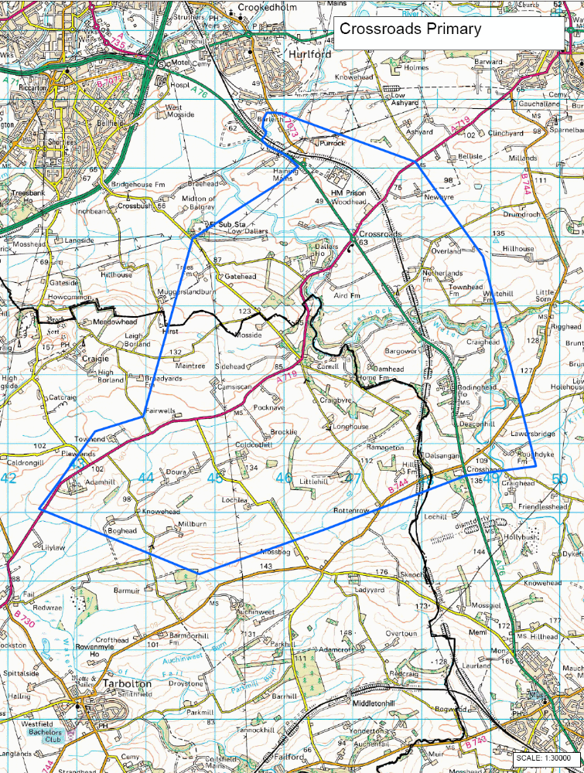

2.2 Accommodation and Capacity

2.2.1 Opened in 1971, Crossroads Primary consists of 3 teaching rooms; there is also a gym hall which encompasses the library and general purpose area, all housed in a flat roof, timber clad building. The building was originally constructed with a life expectancy of 25 years. Within the central corridor is an area which is used for computing and specialist support for pupils. Office accommodation is available for the Head Teacher and clerical assistant and there is also a staffroom.

2.2.2 The planning capacity of a school is calculated by dividing the total area of teaching rooms by the space allocation per child (1.7m²). The working capacity takes account of maximum class sizes, for example, composite classes which are limited to 25 pupils. Based on the Council’s space allocation the classrooms could accommodate 95 pupils; however, due to maximum class sizes for composite classes the capacity of these rooms is limited to 25 each. Therefore, the planning capacity of the school is 95, with a working capacity of 75. There are currently 57 pupils enrolled and therefore 60%.

The school structure presently has 3 composite classes made up as follows :-

Primary 1/2/3, Primary 4/5, and Primary 6/7.

2.3 School Layout

2.3.1 Outline and photographs of Crossroads Primary School building and the school grounds



